**A PROJECT FEASIBILITY STUDY ON THE BUSINESS**

**“ALL RICE”**

**UNIVERSITY OF CEBU - MAIN CAMPUS**

**SANCIANGKO ST., CEBU CITY**

Presented to the

Faculty of College of Business and Accountancy

University of Cebu - Main Campus

In Partial Fulfillment

of the Requirements for the Subject

BA 421 - Feasibility Study

`

GERALD ORLANDA LPT, MBA

Instructor

by:

Sotto, Alexandrea Raeven L.

MONTH, 2025

**APPROVAL SHEET**

This research proposal entitled **TURBOWASH** prepared and submitted by **Alexandrea Raeven L. Sotto** in partial fulfillment of the requirements for the degree **Bachelor of Science in Business Administration major in Financial Management** has been examined and recommended for acceptance and approval for Oral Defense.

**GERALD ORLANDA,** LPT, MBA

Instructor

**PANEL OF EXAMINERS**

Approved by the Committee on Oral Defense with a grade of **Passed.**

Adviser

**JUDE A. SEARES,** CPA, MBA **DANNY D. SUMAGPAO,** DBA

Member Member

**NERMA G. GALLEON,** DBA

Chairman

Accepted and approved in partial fulfillment of the requirements for the Bachelor of Science in Business Administration.

Date of Oral Defense: DATEEE

**MANOLITO C. ALSOLA,** CPA, MBA

Dean, College of Business and Accountancy

**Acknowledgement**

The successful completion of this research would not have been possible without the guidance, support, and encouragement of many individuals who generously contributed their time, expertise, and resources. This study is a product of collective effort, and we wholeheartedly acknowledge everyone who played a role in its success.

First and foremost, we express our deepest gratitude to God Almighty, whose divine wisdom, patience, and strength have guided us through the challenges of this research. His unwavering presence has been our source of motivation, providing us with the perseverance and opportunities necessary to complete this academic endeavor.

We extend our sincere appreciation to our instructor, **Sir Gerald Orlanda**, for his invaluable mentorship, continuous guidance, and insightful feedback, which have been instrumental in shaping this study. We are also profoundly grateful to our esteemed panelists, **Mr. Teodorico A. Bastida Jr., Mr. Danny D. Sumagpao, Mr. Jude A. Seares, and Dr. Generma G. Galleon**, for their expertise and constructive criticism, which have helped refine and strengthen our research.

Our heartfelt gratitude goes to our parents, whose unwavering support and sacrifices have been the foundation of our academic journey. Their encouragement, both emotionally and financially, has given us the confidence to pursue this study with diligence and determination.

Additionally, we extend our sincerest appreciation to our respondents for their willingness to participate and share valuable insights, which were crucial in gathering the necessary data for this research.

Lastly, we express our deepest appreciation to our group members, whose dedication, perseverance, and teamwork have been the driving force behind this project. The collaboration, commitment, and shared efforts of each member have made this study a meaningful and fulfilling experience. This achievement stands as a testament to the power of teamwork and determination.

With gratitude, we acknowledge and honor the contributions of each individual who has supported us in this endeavor.

**MARKETING ASPECT**

# **CHAPTER 1**

# **MARKET STUDY**

**Introduction**  
The rice industry is one of the most essential sectors in the global food market, playing a crucial role in food security, economic stability, and agricultural development. In the Philippines, rice is more than just a staple food—it is a cultural necessity, consumed by nearly every household daily. With an average per capita consumption of 110–120 kilograms per year, the demand for rice remains consistently high, making it one of the most sought-after commodities in the country. The Philippine rice industry thrives on both local production and imports, ensuring a stable supply despite seasonal fluctuations. Major rice-producing regions such as Central Luzon, Cagayan Valley, and Western Visayas contribute significantly to the industry, while government policies regulate imports to balance supply and demand.

Given this strong consumer dependence on rice, there is a growing opportunity for businesses to cater to evolving preferences. In recent years, market trends have indicated an increasing demand for premium, organic, and healthier rice varieties, reflecting a shift toward healthier lifestyles and sustainable food choices. Additionally, the rise of convenience-driven shopping behaviors has opened doors for innovative retail models, such as online distribution and direct-to-consumer sales.

This study evaluates the market potential of All Rice, a retail business aiming to provide high-quality and diverse rice selections to consumers in Brgy. Yati, Liloan. It will assess key market factors such as consumer demand, target customers, competition, and industry trends to determine the feasibility of the business. Understanding these dynamics will help All Rice establish a competitive edge by offering a wide range of rice varieties, competitive pricing, and excellent customer service, all while promoting sustainability and support for local farmers. By addressing these market aspects, All Rice seeks to become a trusted and reliable rice retailer, ensuring long-term business viability while contributing to the local economy.

**PRODUCTS**

All Rice is a retail business that offers a broad variety of rice and these are the various types of rice offered and the description they have.

**Table 1.0** *List of varieties offered*

|  |  |  |
| --- | --- | --- |
| **Products** | **PRODUCT VARIETY** | **DESCRIPTION** |
| https://lh7-rt.googleusercontent.com/docsz/AD_4nXcpYmHHq4xOkTtT6eG9DeMrlc6_8-y7cGCLi8A9jnqsA6cekJbHdazgDA9TQtYMYE_VaLqUlIkmN84L2wjKo6de0Bgt6IIfLjjSP03ucW99rIVz6eSDtVI_2DUJqwcCAQ1fPbi4?key=GGt0KK3Ali6R5vT63MbpQ5iJ | IVORY | Lion Ivory Grains Classic Premium Rice Grown and harvested in the best trade of Cagayan valley, carefully selected crop with finest grains and processed using the latest technology. |
| https://lh7-rt.googleusercontent.com/docsz/AD_4nXeKAUGn6RvBVLSIGsmCRt1J3JBGcMPgS6GVbrbm43XynKmAyR_WMUdE9Kx_HEd9M7KUi5RdSp_aVOd4GpZZvXooM93_NvbZmppZ7CGbOiyIg-tE9XvDBf1UFAuUjsSR14nR7TmCDg?key=GGt0KK3Ali6R5vT63MbpQ5iJ | GANADOR | Ganador is locally grown and produced in Nueva Ecija. But it is already a hybrid rice classified as IR64 rice, which means it is genetically mutated to produce a very good quality of grains in a specific environment/weather. IR64 is the most widely grown rice variety in the tropics like the Philippines. |
| https://lh7-rt.googleusercontent.com/docsz/AD_4nXcQ2VxG5AaZdH0FZI0vqTWY1APPYZnaJnPiiq33rGUrqZhbMq_YYiQBzkhM-ry3c9neN9qpveYWN1YTO0T8dD_s63o6Fy3W1ViPXiXAK7wx9LqvyDFOEQKe2bhjLeYSa0bDkPl7iA?key=GGt0KK3Ali6R5vT63MbpQ5iJ | PRINCESS BEA | Princess Bea rice, often described as a premium, whole-grain rice, is known for being soft, fluffy, and fragrant. It is sometimes referred to as "Princess Bea Red" or "Princess Bea Special Rice". |
| https://lh7-rt.googleusercontent.com/docsz/AD_4nXeVGeQ_DB7CgoBEAxvQ4YqemOQeyiGohE3Kgq_DeWUCKdZh-zvlnTp6MwStNpgBTcQQvikCoh13xxSgPMqK6y27baCZBrdDUGTSF11f3gZsrca489z8av9h53_oCeaW2ivUd_lT?key=GGt0KK3Ali6R5vT63MbpQ5iJ | DOÑA CONCHITA  (blue&orange) | Doña Conchita is a premium quality imported rice from Vietnam with an exquisite blend of stickiness and softness that will exceed expectations. With its captivating aroma, each grain tantalizes the senses, making it perfect for traditional Filipino dishes. |
| https://lh7-rt.googleusercontent.com/docsz/AD_4nXfKJWYQMb7TRjWoxD1107pryJPRpnreqOjNC4dbmpVnbFlYh-LhP_0DrQw42WS3N15fO7oVHYQB0RV1Kg3Jj4J8eQD-n4IHHX2UIkGOqV26gaBoqwirUNFxckt9LuXkpWgbS6PB?key=GGt0KK3Ali6R5vT63MbpQ5iJ | BROWN RICE | This variety is a whole-grain rice that retains its bran layer, rendering it more nutrient-dense compared to white rice. Typically displaying a tan or light brown hue, it serves as the  "unrefined" counterpart to white rice. Due to its composition, it often feels "lighter" in the stomach and may contribute to preventing insulin spikes, facilitating quicker digestion. |
| https://lh7-rt.googleusercontent.com/docsz/AD_4nXexz244-CFf3UYwytkiuGRVycHzcgWBUnnYG-KTGsKp9PTDoARCo2d0uovNHbYEAwIbMEtpdapyyP5Ib1HyVI-TCuPDLi0jV2SETkRFJoWFWgX3d-Vl85_j6rH190AHYYoIs7wa?key=GGt0KK3Ali6R5vT63MbpQ5iJ | CORN  (14&16) | White corn rice, also known as "Bigas Mais," is a popular rice alternative and is a good source of fiber, vitamins, and minerals. It's a good substitute for white rice, especially for those with dietary restrictions or seeking a healthier option. It is known for its lower glycemic index, which can help regulate blood sugar levels, making it suitable for individuals with diabetes or those watching their blood sugar levels. |
| https://lh7-rt.googleusercontent.com/docsz/AD_4nXew29KtfvP690iTaWoRUNfPqWDDRX9371PXZd-zCqo81D7Q1k2WxQxeomyndtNEykfBYNmltsWZTn6uDbCwKWEVivxr4ZE38tl-bK2Xkf0ak2WIg4u6cPSOixcVaj5VntuDl3NVRQ?key=GGt0KK3Ali6R5vT63MbpQ5iJ | GLUTINOUS RICE | Glutinous rice, also known as sticky or sweet rice, is a short-grain rice variety characterized by its sticky, chewy texture when cooked, and is often used in Filipino cuisine for both savory and sweet dishes. Unlike long-grain rice, glutinous rice has a shorter, rounded grain shape. It is generally low in fat and cholesterol |
|  | MIX RICE | **Mix Rice** is a customizable blend of **two different rice varieties**, allowing customers to choose their preferred combination based on taste, texture, and budget. Whether opting for an **equal mix (½ of each variety)** or a **specific ratio (e.g., ¾ of one and ¼ of another),** customers can create a blend that suits their needs. A **list of approved rice varieties** is available. This option provides flexibility, affordability, and a unique rice experience—perfect for households and businesses looking for variety and value. |

**USES OF THE PRODUCT**

Rice is an essential part of the Filipino diet, serving not only as a daily staple but also as a versatile ingredient that enhances the richness of Filipino cuisine. Across households in the Philippines, rice is enjoyed in various forms — from a simple side dish to the foundation of flavorful meals such as fried rice, rice bowls, hearty stews, and comforting rice-based soups. Signature Filipino specialties like arroz caldo and champorado further highlight the adaptability of rice in both savory and sweet creations.

Beyond its role in everyday dining, rice is a fundamental ingredient in many iconic Filipino dishes, including sinigang, adobo, kare-kare, and Bicol express. Its ability to complement bold flavors and rich sauces makes rice indispensable in Filipino culinary tradition. To meet diverse preferences and dietary needs, Filipino families turn to different rice varieties: white rice for everyday meals, glutinous rice for traditional desserts, brown rice for a healthier alternative, and corn rice, a gluten-free option that offers a unique flavor and texture.

Rice also holds profound cultural significance in the Philippines. It is at the heart of religious ceremonies, harvest festivals, and agricultural celebrations — symbolizing abundance, prosperity, and gratitude. This deep-rooted cultural connection reflects the enduring importance of rice, not only as a source of nourishment but also as a symbol of Filipino heritage and identity.

From everyday meals to festive celebrations, rice continues to play an irreplaceable role in Filipino life. As a trusted provider of high-quality rice products, All Rice is proud to offer a wide selection of premium rice varieties — ensuring that every Filipino family has access to the right type of rice for every occasion, whether for traditional cooking, modern recipes, or healthy lifestyle choices.

Rice is more than just food; it is the heart of every Filipino meal — bringing families together, enriching every dish, and turning ordinary moments into meaningful memories. With All Rice, you are not just choosing rice — you are choosing quality, tradition, and a taste of home in every grain.

**TARGET MARKET**

All Rice is a retail business focused on providing high-quality varieties of rice to meet the diverse needs of its customers. The business is located in Brgy. Yati, Liloan, which, according to the 2020 Census, has a population of 37,046 with 7,930 households, representing 24.18% of the total population of Liloan. The target demographic for All Rice encompasses individuals of all ages and genders- men, women, young, old- who incorporate rice into their diet. The primary target market for All Rice is households in Brgy. Yati, as rice is a staple food in many kitchens and is consumed daily by families across various demographics. These households are seeking convenient, reliable, and nutritious rice options for their meals.

In addition to households, another potential target market includes small local food businesses, such as food stalls, small eateries, and cafes in the area. These businesses require a steady supply of rice in smaller quantities. By focusing on both households and local food vendors, All Rice can establish a broad and sustainable customer base while addressing the rice needs of different segments within the community.

**GEOGRAPHICAL AREAS OF DISPERSION**

The business is located in Liloan, specifically in Brgy. Yati, 4131 Cebu N Rd. Liloan is a first-income class municipality situated within Metro Cebu on the islands of the Visayas, Central Philippines. Liloan consists of 14 barangays, and 237 puroks, covering a total land area of approximately 5,210 hectares. The business is strategically positioned near the market, surrounded by other establishments such as a salon, small cafes, department store, food stalls, small eateries, and even Seven-Eleven, ensuring a steady flow of people passes by daily. Currently, there is only one small direct competitor in the immediate vicinity, offering a favorable advantage for the business.

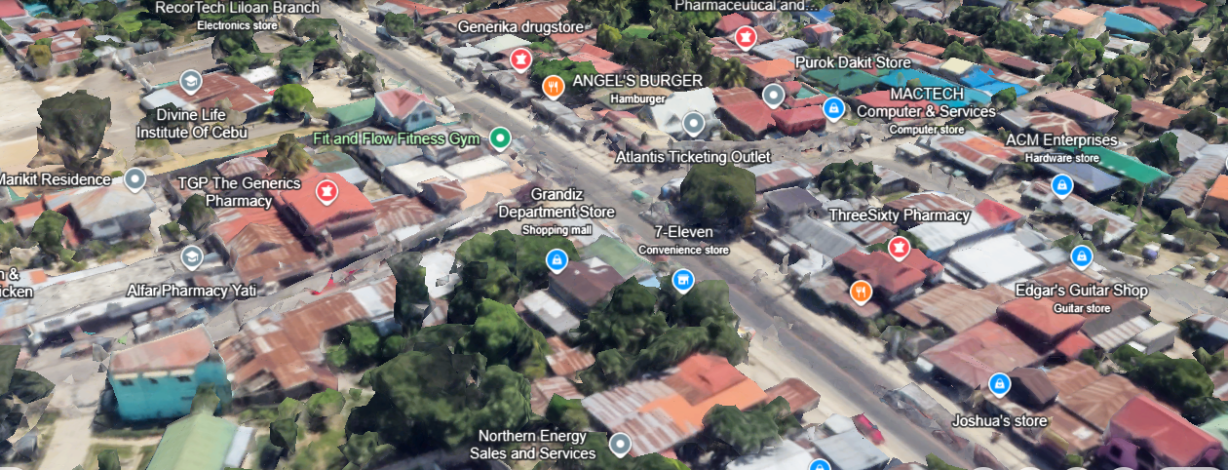

**Figure 1.0** *Geographical Areas of Dispersion*

**MARKET DESCRIPTION**

The Philippine rice market plays a vital role in the country’s economy, culture, and daily life. As a staple food consumed by nearly every Filipino household, rice holds unparalleled importance across all socioeconomic segments, from urban centers to rural communities. With rice being an essential part of every meal, demand remains consistently high throughout the year, making it one of the most significant and stable sectors in the local food industry.

The rice market is also evolving, with Filipino consumers becoming more health-conscious and open to exploring alternative rice varieties, including brown rice for its nutritional benefits and corn rice for its gluten-free properties. This diversification reflects a growing preference for healthier lifestyles while maintaining the cultural significance of rice as a staple food.

As a trusted provider, All Rice is well-positioned to meet these diverse consumer demands by offering a wide selection of high-quality rice varieties — from white rice for everyday meals, to glutinous rice for traditional delicacies, to healthier and specialty options that align with modern dietary preferences.

The business is strategically located in Brgy. Yati, Liloan, ensuring easy accessibility for its target market. It is surrounded by various business establishments, including a department store, local market, food stalls, small eateries, convenience stores like 7-Eleven, and cafés, making it a convenient stop for both residents and passersby. Additionally, the store is near a school, church, and dental clinic, and is situated along a busy roadside, ensuring a steady flow of potential customers daily. This prime location enhances the store’s visibility and attracts both local residents and non-residents, expanding its customer reach.

To further accommodate busy customers, the business also offers online selling, allowing customers and consumers who do not have time to shop in-store to place orders conveniently. Purchased rice will be delivered directly to their respective homes, with a minimal delivery fee, ensuring a seamless and hassle-free shopping experience.

By understanding the unique preferences and evolving needs of Filipino families, All Rice continues to serve as a reliable partner in every household’s journey to create delicious, meaningful, and nourishing meals.

**SURVEY**

The researchers conducted a structured survey based on a population of 37,046, according to the 2020 census, to gather valuable information for the proposed business venture. The sample size counts to 381 respondents determined using this population. The primary goal of this survey was to gain insights into the perspectives and preferences of potential customers.

Through this survey, the researchers aimed to collect factual, research-based data directly from individuals representing the target market. The survey likely included questions about the proposed business’s products or services, pricing, location, and other relevant factors.

**Research Instrument**

The proponents designed a structured survey questionnaire as the primary research instrument, utilizing face-to-face interactions to gather data. The survey consisted of twenty (17) carefully crafted questions, along with other prompts, to collect relevant information from participants. It aimed to assess the needs and preferences of potential customers.

Each question was thoughtfully designed to provide valuable insights, enabling All Rice to refine its services, enhance customer satisfaction, and implement effective business strategies based on consumer expectations. The proponents selected English as the instruction language and patiently explained the instructions and questions to respondents to ensure clarity and understanding before they answered

**SOLUTION FOR FINDING THE NUMBER OF RESPONDENTS**

The proponents used the Raosoft sample size calculator:

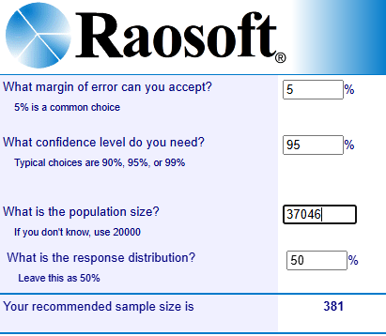

**Figure 1.1** *Sample Size Determination*

**CONSOLIDATED SURVEY RESULT AND INTERPRETATION**

The proponents surveyed 381 households to become respondents which were randomly selected from Barangay Yati, Liloan. Respondents carefully completed the survey questionnaire and the information acquired will be used to examine the effectiveness of the business. After the required number of respondents have taken the survey, the results will then be analyzed and interpreted in a way that helps the proponents understand the customers and improve the proposed business.

The following are the results of the survey:

**Q1. Household Income Range**

**Table 1.1** *Results for question number 1*

|  |  |  |
| --- | --- | --- |
| Possible Answer | No. of Respondents | Percentage |
| Below ₱10,000 | 69 | 18.11% |
| ₱10,000 - ₱30,000 | 225 | 59.06% |
| ₱30,001 - ₱50,000 | 59 | 15.49% |
| ₱50,001 - ₱100,000 | 20 | 5.25% |
| Above ₱100,000 | 8 | 2.10% |
| Grand Total | 381 |  |

**Table 1.1** shows that the majority of respondents (59.06%) have a household income ranging from **₱10,000 to ₱30,000**. This is followed by **18.11%** earning **below ₱10,000** and **15.49%** earning between **₱30,001 and ₱50,000**. A smaller portion of respondents fall within the **₱50,001 to ₱100,000** range (5.25%) and **above ₱100,000** (2.10%). This indicates that most households have a **low to moderate income** level.

**Q2. Household size**

Table 1.2 *Results for question number 2*

|  |  |  |
| --- | --- | --- |
| Possible Answers | No. of Respondents | Percentage |
| 1-2 members | 76 | 19.95% |
| 3-5 members | 219 | 57.48% |
| More than 5 members | 86 | 22.57% |
| Grand Total | 381 |  |

**Table 1.2** shows that the majority of respondents (**57.48%**) live in households with **3–5 members**, indicating that medium-sized families are the most common. Meanwhile, **22.57%** of respondents come from households with **more than 5 members**, and **19.95%** have **1–2 members**, suggesting that smaller households are less prevalent in the sample.

**Q3. Does your household eat rice daily?**

Table 1.3 *Results for question number 3*

|  |  |  |
| --- | --- | --- |
| Possible Answer | No. of Respondents | Percentage |
| No | 2 | 0.52% |
| Yes | 379 | 99.48% |
| Grand Total | 381 |  |

Table 1.3 shows that 99.48% of respondents stated their household eats rice daily, confirming that rice is a staple food in nearly all households surveyed. Only 0.52% reported not consuming rice daily, indicating minimal variation in rice consumption habits.

**Q4. Do you prefer eating rice in your meals?**

Table 1.4 *Results for question number 4*

|  |  |  |
| --- | --- | --- |
| Possible Answer | No. of Respondents | Percentage |
| Yes | 379 | 100% |
| Grand Total | 379 |  |

**Table 1.4** shows that **100% of the respondents** prefer eating rice in their meals. This clearly indicates that rice is a staple food and highly favored among all respondents.

**Q5. How much rice does your household consume per month?**

Table 1.5 *Results for question number 5*

|  |  |  |
| --- | --- | --- |
| Possible Answer | No. of Respondents | Percentage |
| 5 to 10 kg | 74 | 19.53% |
| 11 to 20 kg | 151 | 39.84% |
| More than 20 kg | 154 | 40.63% |
| Grand Total | 379 |  |

**Table 1.5** shows that most households consume **more than 20 kg of rice per month** (40.63%), followed closely by those consuming **11 to 20 kg** (39.84%). A smaller portion (19.53%) consumes only **5 to 10 kg**, suggesting that the majority of households have a high monthly rice consumption.

**Q6. How often do you purchase rice?**

Table 1.6 *Results for question number 6*

|  |  |  |
| --- | --- | --- |
| Possible Answer | No. of Respondents | Percentage |
| Daily | 66 | 17.41% |
| 2-3 times a week | 87 | 22.96% |
| 4-5 times a week | 13 | 3.43% |
| Once a week | 107 | 28.23% |
| every 15 days | 4 | 1.06% |
| Monthly | 102 | 26.91% |
| Grand Total | 379 |  |

**Table 1.6** shows that the majority of respondents purchase rice **once a week** (28.23%), followed closely by those who buy it **monthly** (26.91%). A notable portion purchases rice **2–3 times a week** (22.96%), while **17.41%** buy it **daily**. A smaller percentage purchase **4–5 times a week** (3.43%) and **every 15 days** (1.06%). This indicates that most households prefer to buy rice on a **weekly or monthly** basis.

**Q7: What packaging size do you usually prefer?**

Table 1.7 *Results for question number 7*

|  |  |  |
| --- | --- | --- |
| Possible Answer | No. of Respondents | Percentage |
| By kilos | 101 | 26.6% |
| 5 kilos | 69 | 18.2% |
| 10 kilos | 59 | 15.6% |
| 25 kilos | 37 | 9.8% |
| By sacks | 113 | 29.8% |
| Grand Total | 379 | 100% |

**Table 1.7** reveals that the most preferred packaging size is **by sacks** (29.8%), followed by **by kilos** (26.6%). Among specific kilo options, **5 kilos** is preferred by **18.2%**, **10 kilos** by **15.6%**, and **25 kilos** by **9.8%**. This suggests that bulk purchasing, especially by sacks, is slightly more favored than buying by smaller kilo quantities.

**Q8. What brands of white rice do you prefer to purchase?**

**Table 1.8** *Results for question number 8*

|  |  |  |
| --- | --- | --- |
| **Possible Answer** | **No. of Respondents** | **Percentage** |
| Jaguar | 4 | 1.06% |
| Sinandomeng | 4 | 1.06% |
| Dinorado | 5 | 1.32% |
| Jasmine | 5 | 1.32% |
| Dona Conchita (orange) | 26 | 6.86% |
| Dona Conchita (blue) | 28 | 7.39% |
| Princess Bea | 41 | 10.82% |
| Ivory | 125 | 32.98% |
| Ganador | 141 | 37.20% |
| **Grand Total** | 379 |  |

**Q9. Other than white rice, what type of rice do you usually buy?**

**Table 1.9** *Results for question number 9*

|  |  |  |
| --- | --- | --- |
| **Possible Answer** | **No. of Respondents** | **Percentage** |
| Pink Rice | 1 | 0.26% |
| Red Rice | 9 | 2.37% |
| Just White Rice | 23 | 6.07% |
| Malagkit (Glutinous) Rice | 53 | 13.98% |
| Corn Rice (14) | 90 | 23.75% |
| Brown Rice | 93 | 24.54% |
| Corn Rice (16) | 110 | 29.02% |
| **Grand Total** | 379 |  |

**Q10. Where do you usually purchase your rice from?**

**Table 1.10** *Results for question number 10*

|  |  |  |
| --- | --- | --- |
| **Possible Answer** | **No. of Respondents** | **Percentage** |
| Wholesale stores | 41 | 10.82% |
| Supermarket | 43 | 11.35% |
| Local markets | 295 | 77.84% |
| **Grand Total** | **379** |  |

**Q11**. **Which type of rice do you prefer to buy?**

**Table 1.11** *Results for question number 11*

|  |  |  |
| --- | --- | --- |
| **Possible Answer** | **No. of Respondents** | **Percentage** |
| Imported Rice | 15 | 3.96% |
| It doesn’t Matter | 100 | 26.39% |
| Local Rice | 264 | 69.66% |
| **Grand Total** | **379** |  |

**Q12**. **Would you like to try new types of rice?**

**Table 1.12** *Results for question number 12*

|  |  |  |
| --- | --- | --- |
| **Possible Answer** | **No. of Respondents** | **Percentage** |
| No | 77 | 20.32% |
| Maybe | 86 | 22.69% |
| Yes | 216 | 56.99% |
| **Grand Total** | **379** |  |

**Q13**. **If we open a rice store near your location, will you purchase from us?**

**Table 1.13** *Results for question number 13*

|  |  |  |
| --- | --- | --- |
| **Possible Answer** | **No. of Respondents** | **Percentage** |
| No | 10 | 2.64% |
| Maybe | 59 | 11.61% |
| Yes | 310 | 85.75% |
| **Grand Total** | **379** | 100.00% |

**Q14**. **Would you be interested in rice delivery services? (with delivery fee)**

**Table 1.14** *Results for question number 14*

|  |  |  |
| --- | --- | --- |
| **Possible Answer** | **No. of Respondents** | **Percentage** |
| Maybe | 46 | 12.14% |
| No | 62 | 16.36% |
| Yes | 271 | 71.50% |
| **Grand Total** | 379 | 100.00% |

**Q15**. **Would you be interested in a loyalty program (discounts/rewards for frequent buyers)?**

**Table 1.15** *Results for question number 15*

|  |  |  |
| --- | --- | --- |
| **Possible Answer** | **No. of Respondents** | **Percentage** |
| No | 35 | 9.23% |
| Yes | 344 | 90.77% |
| **Grand Total** | 379 | 100.00% |

**Q16**. **What additional services would you like us to provide? (Check all that apply)**

**Table 1.16** *Results for question number 16*

|  |  |  |
| --- | --- | --- |
| **Possible Answer** | **No. of Respondents** | **Percentage** |
| Educational information on rice nutrition and cooking tips | 33 | 6.29% |
| Bulk discounts | 78 | 14.86% |
| Rice subscription (weekly/monthly supply) | 83 | 15.81% |
| Custom rice blending (mixing different rice varieties) | 145 | 27.62% |
| Home delivery | 186 | 35.43% |
| **Grand Total** | **525** | 100.00% |

**Q17**.  **What improvements would you like to see in rice products?**

**Table 1.17** *Results for question number 17*

|  |  |  |
| --- | --- | --- |
| Possible Answer | **No. of Respondents** | **Percentage** |
| Improved packaging | 9 | 1.63% |
| More variety | 27 | 4.89% |
| Clean and secure environment | 151 | 27.36% |
| Lower prices | 164 | 29.71% |
| Better quality | 201 | 36.41% |
| Grand Total | 552 | 100.00% |

**DEMAND ANALYSIS**

The current study consisted of one primary method for evaluating the necessity and demand for the establishment of All Rice in Barangay Yati, Liloan Cebu for the last five (5) years. This method consisted of surveying relevant populations and their insights and opinions regarding the proposed business.

**Historical Demand**

**Table 1.8** *Population Data for the last 5 years*

|  |  |  |
| --- | --- | --- |
| **Number of Households** | | |
| **YEAR** | **POPULATION** | **HOUSEHOLD** |
| 2020 | 37,046 | 7,930 |
| 2021 | 38,046 | 8,203 |
| 2022 | 39,046 | 8,479 |
| 2023 | 40,046 | 8,759 |
| 2024 | 41,046 | 9,327 |

Table 1.8 Presents the estimated population and household of Barangay Yati, Liloan,Cebu from 2020 to 2024. The data was gathered from local population records, reflecting the yearly growth in the barangay.

**Historical Demand for the Last Five Years**

**Table 1.9** *Market Acceptability*

|  |  |  |  |
| --- | --- | --- | --- |
| **Years** | **Number of Households** | **Percentage in Q3 that answered “Yes”** | **Market Acceptability** |
| 2020 | 7,930 | 99.48% | 7,889 |
| 2021 | 8,203 | 99.48% | 8,160 |
| 2022 | 8,479 | 99.48% | 8,435 |
| 2023 | 8,759 | 99.48% | 8,713 |
| 2024 | 9,327 | 99.48% | 9,278 |

**Table 1.10** *Historical Demand for 2020*

|  |  |  |  |
| --- | --- | --- | --- |
| **Category** | **Market Acceptability** | **Percentage**  **Question #6** | **Demand Per Category** |
| Daily | 7,889 | 17.41% | 1,373 |
| 2-3 times a week | 7,889 | 22.96% | 1,811 |
| 4-5 times a week | 7,889 | 3.43% | 271 |
| Once a week | 7,889 | 28.23% | 2,227 |
| every 15 days | 7,889 | 1.06% | 84 |
| Monthly | 7,889 | 26.91% | 2,123 |
| **TOTAL** | | | **7,889** |

**Table 1.11** *Historical Demand for 2021*

|  |  |  |  |
| --- | --- | --- | --- |
| **Category** | **Market Acceptability** | **Percentage**  **Question #6** | **Demand Per Category** |
| Daily | 8,160 | 17.41% | 1,421 |
| 2-3 times a week | 8,160 | 22.96% | 1,874 |
| 4-5 times a week | 8,160 | 3.43% | 280 |
| Once a week | 8,160 | 28.23% | 2,304 |
| every 15 days | 8,160 | 1.06% | 86 |
| Monthly | 8,160 | 26.91% | 2,196 |
| **TOTAL** | | | **8,160** |

**Table 1.12** *Historical Demand for 2022*

|  |  |  |  |
| --- | --- | --- | --- |
| **Category** | **Market Acceptability** | **Percentage**  **Question #6** | **Demand Per Category** |
| Daily | 8,479 | 17.41% | 1,476 |
| 2-3 times a week | 8,479 | 22.96% | 1,947 |
| 4-5 times a week | 8,479 | 3.43% | 291 |
| Once a week | 8,479 | 28.23% | 2,394 |
| every 15 days | 8,479 | 1.06% | 90 |
| Monthly | 8,479 | 26.91% | 2,282 |
| **TOTAL** | | | **8,479** |

**Table 1.13** *Historical Demand for 2023*

|  |  |  |  |
| --- | --- | --- | --- |
| **Category** | **Market Acceptability** | **Percentage**  **Question #6** | **Demand Per Category** |
| Daily | 8,713 | 17.41% | 1,517 |
| 2-3 times a week | 8,713 | 22.96% | 2,001 |
| 4-5 times a week | 8,713 | 3.43% | 299 |
| Once a week | 8,713 | 28.23% | 2,460 |
| every 15 days | 8,713 | 1.06% | 92 |
| Monthly | 8,713 | 26.91% | 2,345 |
| **TOTAL** | | | **8,713** |

**Table 1.14** *Historical Demand for 2024*

|  |  |  |  |
| --- | --- | --- | --- |
| **Category** | **Market Acceptability** | **Percentage**  **Question #6** | **Demand Per Category** |
| Daily | 9,278 | 17.41% | 1,615 |
| 2-3 times a week | 9,278 | 22.96% | 2,130 |
| 4-5 times a week | 9,278 | 3.43% | 318 |
| Once a week | 9,278 | 28.23% | 2,619 |
| every 15 days | 9,278 | 1.06% | 98 |
| Monthly | 9,278 | 26.91% | 2,497 |
| **TOTAL** | | | **9,278** |

**Table 1.15** *Historical Demand Analysis Per Year*

|  |  |  |  |
| --- | --- | --- | --- |
| **Years** | **Actual Volume** | **No. of Months** | **Total Historical Demand** |
| 2020 | 7,889 | 12 | 94,668 |
| 2021 | 8,160 | 12 | 97,920 |
| 2022 | 8,479 | 12 | 101,748 |
| 2023 | 8,713 | 12 | 104,556 |
| 2024 | 9,278 | 12 | 111,336 |

**Table 1.16** *Historical Demand for Actual Volume*

|  |  |  |  |  |  |
| --- | --- | --- | --- | --- | --- |
| **Categories** | **2020** | **2021** | **2022** | **2023** | **2024** |
| Historical Demand Per Year | 94,668 | 97,920 | 101,748 | 104,556 | 111,336 |
| (Q5) Consumption Per Month | **5-10 kg (19.53%)** | | | | |
| Actual Kilos | 18,489 | 19,124 | 19,871 | 20,420 | 21,744 |
| (Q5) Consumption Per Month | **11-20 kg (39.84%)** | | | | |
| Actual Kilos | 37,716 | 39,011 | 40,536 | 41,655 | 44,356 |
| (Q5) Consumption Per Month | **More than 20 kg (40.63%)** | | | | |
| Actual Kilos | 38,464 | 39,785 | 41,340 | 42,481 | 45,236 |
| **TOTAL:** | 94,669 | 97,920 | 101,747 | 104,556 | 111,336 |

**Table 1.15** *Historical Demand Per Year In Kilos*

|  |  |
| --- | --- |
| **Years** | **Actual Demand** |
| 2020 | 94,668 |
| 2021 | 97,920 |
| 2022 | 101,748 |
| 2023 | 104,556 |
| 2024 | 111,336 |

**Projected Demand**  
In computing the projected demand for the next five (5) years, the proponents used the arithmetic straight-line method.

**Arithmetic Straight-Line Method**

**Step 1:** Get the difference between the first year and the last year.

Historical demand for the last year (2024) **111,336**

Historical demand for first year (2020) **94,668**

**Increase in Demand= 16,668**

**Step 2:** Get the average increase by dividing the result of the computation in step one by the number of years.

16,668/5= **3,333.6 / 3,334**

**Step 3**: Compute the Projected demand  
  
                                           **Table 1.17** *Projected Demand for the Next Five Years*

|  |  |  |
| --- | --- | --- |
| **Years** | **Projected Years** | **Projected Demand** |
| 2026 | 111,336+3,334 | 114,670 |
| 2027 | 114,670+3,334 | 118,004 |
| 2028 | 118,004+3,334 | 121,338 |
| 2029 | 121,338+3,334 | 124,672 |
| 2030 | 124,672+3,334 | 128,006 |

Table 2.6: Shows the computation of the projected demand of the product for five years.

**Table 1.18** *Projected Demand Per Variety*

|  |  |  |  |  |  |  |
| --- | --- | --- | --- | --- | --- | --- |
| **Variety** | **Percentage Q 8,9,16** | **2026**  114,670 | **2027**  118,004 | **2028**  121,338 | **2029**  124,672 | **2030**  128,006 |
| Dona Conchita (orange) | **6.86%** | 7,866 | 8,095 | 8,324 | 8,552 | 8,781 |
| Dona Conchita (blue) | **7.39%** | 8,474 | 8,720 | 8,967 | 9,213 | 9,460 |
| Princess Bea | **10.82%** | 12,407 | 12,768 | 13,129 | 13,490 | 13,850 |
| Ivory | **32.98%** | 37,818 | 38,918 | 40,017 | 41,117 | 42,216 |
| Ganador | **37.20%** | 42,657 | 43,897 | 45,138 | 46,378 | 47,618 |
| Malagkit (Glutinous) Rice | **13.98%** | 16,031 | 16,497 | 16,963 | 17,429 | 17,895 |
| Corn Rice (14) | **23.75%** | 27,234 | 28,026 | 28,818 | 29,610 | 30,401 |
| Brown Rice | **24.54%** | 28,140 | 28,958 | 29,776 | 30,595 | 31,413 |
| Corn Rice (16) | **29.02%** | 33,277 | 34,245 | 35,212 | 36,180 | 37,147 |
| Mix Rice | **27.62%** | 31,672 | 32,593 | 33,514 | 34,434 | 35,355 |

**SUPPLY ANALYSIS**

**Supply** refers to the amount of a product that a seller is willing to offer in the market at a particular moment over a predetermined period of time. Since customer satisfaction is a primary concern for businesses, understanding supply is vital for determining how many products to produce to meet consumer demand.

**Historical Supply**

**Table 1.17** *Estimated* *Historical Supply (Per Kilo)*

|  |  |  |  |  |  |
| --- | --- | --- | --- | --- | --- |
| **Years** | **Competitor** | **Estimated sold per Kilo in a Month** | **No. of**  **Months** | **Historical**  **Supply** | **Historical Supply In Kilos** |
| 2020 | Tata’s Store | 100kl | 12 | 1,200 kg | 1,200 |
| 2021 | 150kl | 12 | 1,800 kg | 1,800 |
| 2022 | 150kl | 12 | 1,800 kg | 1,800 |
| 2023 | 200kl | 12 | 2,400 kg | 2,400 |
| 2025 | 200kl | 12 | 2,400 kg | 2,400 |
| **Total** |  | | | | **9,600** |
| **Years** | **Competitor** | **Estimated sold per Kilo in a Month** | **No. of Months** | **Historical**  **Supply** | **Historical Supply In Kilos** |
| 2020 | Bugasan ni Jennifer | 80kl | 12 | 960 kg | 960 |
| 2021 | 150kl | 12 | 1800 kg | 1800 |
| 2022 | 150kl | 12 | 1800 kg | 1800 |
| 2023 | 100kl | 12 | 1200 kg | 1200 |
| 2025 | 150kl | 12 | 1800 kg | 1800 |
| **Total** |  | | |  | **7,560** |

**Table 1.18** *Estimated Historical Supply (Per Sack 5kg)*

|  |  |  |  |  |  |
| --- | --- | --- | --- | --- | --- |
| **Years** | **Competitor** | **Estimated sold per 5 Sacks in a Month** | **No. of Months** | **Historical**  **Supply** | **Historical Supply In Kilos** |
| 2020 | Tata’s Store | 15 sacks | 12 | 180 | 900 |
| 2021 | 20 sacks | 12 | 240 | 1,200 |
| 2022 | 20 sacks | 12 | 240 | 1,200 |
| 2023 | 50 sacks | 12 | 600 | 3,000 |
| 2025 | 55 sacks | 12 | 660 | 3,300 |
| **Total** |  | | | | **9,600** |
| **Years** | **Competitor** | **Estimated sold per 5 Sacks in a Month** | **No. of Months** | **Historical**  **Supply** | **Historical Supply In Kilos** |
| 2020 | Bugasan ni Jennifer | 20 sacks | 12 | 240 | 1,200 |
| 2021 | 25 sacks | 12 | 300 | 1,500 |
| 2022 | 30 sacks | 12 | 360 | 1,800 |
| 2023 | 30 sacks | 12 | 360 | 1,800 |
| 2025 | 50 sacks | 12 | 600 | 3,000 |
| **Total** |  | | | | **9,300** |

**Table 1.19** *Estimated Historical Supply (Per Sack 10kg)*

|  |  |  |  |  |  |
| --- | --- | --- | --- | --- | --- |
| **Years** | **Competitor** | **Estimated sold per 10 Sacks in a Month** | **No. of Months** | **Historical**  **Supply** | **Historical Supply In Kilos** |
| 2020 | Tata’s Store | 5 sacks | 12 | 60 | 600 |
| 2021 | 10 sacks | 12 | 120 | 1,200 |
| 2022 | 20 sacks | 12 | 240 | 2,400 |
| 2023 | 20 sacks | 12 | 240 | 2,400 |
| 2025 | 30 sacks | 12 | 360 | 3,600 |
| **Total** |  | | | | **10,200** |
| **Years** | **Competitor** | **Estimated sold per 10 Sacks in a Month** | **No. of**  **Months** | **Historical**  **Supply** | **Historical Supply In Kilos** |
| 2020 | Bugasan ni Jennifer | 5 sacks | 12 | 60 | 600 |
| 2021 | 15 sacks | 12 | 180 | 1,800 |
| 2022 | 10 sacks | 12 | 120 | 1,200 |
| 2023 | 20 sacks | 12 | 240 | 2,400 |
| 2025 | 20 sacks | 12 | 240 | 2,400 |
| **Total** |  | | | | **8,400** |

**Table 1.20** *Estimated Historical Supply (Per Sack 25kg)*

|  |  |  |  |  |  |
| --- | --- | --- | --- | --- | --- |
| **Years** | **Competitor** | **Estimated sold per 25 Sacks in a Month** | **No. of**  **Months** | **Historical**  **Supply** | **Historical Supply In Kilos** |
| 2020 | Tata’s Store | 10 sacks | 12 | 120 | 3,000 |
| 2021 | 30 sacks | 12 | 360 | 9,000 |
| 2022 | 30 sacks | 12 | 360 | 9,000 |
| 2023 | 40 sacks | 12 | 480 | 12,000 |
| 2025 | 40 sacks | 12 | 480 | 12,000 |
| **Total** |  | | | | **45,000** |
| **Years** | **Competitor** | **Estimated sold per 25 Sacks in a Month** | **No. of Months** | **Historical**  **Supply** | **Historical Supply In Kilos** |
| 2020 | Bugasan ni  Jennifer | 10 sacks | 12 | 120 | 3,000 |
| 2021 | 20 sacks | 12 | 240 | 6,000 |
| 2022 | 30 sacks | 12 | 360 | 9,000 |
| 2023 | 30 sacks | 12 | 360 | 9,000 |
| 2025 | 30 sacks | 12 | 360 | 9,000 |
| **Total** |  | | | | **36,000** |

**Table 1.21** *Estimated Historical Supply (Per Sack 50kg)*

|  |  |  |  |  |  |
| --- | --- | --- | --- | --- | --- |
| **Years** | **Competitor** | **Estimated sold per Sack in a Month** | **No. of Months** | **Historical**  **Supply** | **Historical Supply In Kilos** |
| 2020 | Tata’s Store | 20 sacks | 12 | 240 | 12,000 |
| 2021 | 30 sacks | 12 | 360 | 18,000 |
| 2022 | 30 sacks | 12 | 360 | 18,000 |
| 2023 | 20 sacks | 12 | 240 | 12,000 |
| 2025 | 20 sacks | 12 | 240 | 12,000 |
| **Total** |  | | | | **72,000** |
| **Years** | **Competitor** | **Estimated sold per Sack in a Month** | **No. of Months** | **Historical**  **Supply** | **Historical Supply In Kilos** |
| 2020 | Bugasan ni Jennifer | 20 sacks | 12 | 240 | 12,000 |
| 2021 | 30 sacks | 12 | 360 | 18,000 |
| 2022 | 30 sacks | 12 | 360 | 18,000 |
| 2023 | 20 sacks | 12 | 240 | 12,000 |
| 2025 | 15 sacks | 12 | 180 | 9,000 |
| **Total** |  | | | | **69,000** |

**Table 1.22** *Computation for the Estimated Supply in Kilo*

|  |  |  |  |  |  |  |
| --- | --- | --- | --- | --- | --- | --- |
| **Tata’s Store** | **1 kg** | **Per Sack 5kg** | **Per Sack**  **10kg** | **Per Sack 25kg** | **Per Sack**  **50kg** | **Total** |
| 2020 | 1,200 | 900 | 600 | 3,000 | 12,000 | 17,700 |
| 2021 | 1,800 | 1,200 | 1,200 | 9,000 | 18,000 | 31,200 |
| 2022 | 1,200 | 2,400 | 9,000 | 18,000 | 18,000 | 32,400 |
| 2023 | 3,000 | 2,400 | 12,000 | 12,000 | 12,000 | 31,800 |
| 2024 | 3,300 | 3,600 | 12,000 | 12,000 | 12,000 | 33,300 |
| TOTAL: |  | | | | | **146,400** |
| **Bugasan Ni**  **Jennifer** | **1 kg** | **Per Sack 5kg** | **Per Sack**  **10kg** | **Per Sack 25kg** | **Per Sack**  **50kg** | **Total** |
| 2020 | 960 | 1,200 | 600 | 3,000 | 12,000 | 17,760 |
| 2021 | 1800 | 1,500 | 1,800 | 6,000 | 18,000 | 29,100 |
| 2022 | 1800 | 1,800 | 1,200 | 9,000 | 18,000 | 31,800 |
| 2023 | 1,200 | 1,800 | 2,400 | 9,000 | 12,000 | 26,400 |
| 2024 | 1800 | 3,000 | 2,400 | 9,000 | 9,000 | 25,200 |
| TOTAL: |  | | | | | **130,260** |

**Table 1.23** *Distribution of Historical Supply in Kilo*

|  |  |  |  |  |  |
| --- | --- | --- | --- | --- | --- |
| **Competitor** | **2020** | **2021** | **2022** | **2023** | **2024** |
| Tata’s Store | 17,700 | 31,200 | 32,400 | 31,800 | 33,300 |
| Bugasan ni Jennifer | 17,760 | 29,100 | 31,800 | 26,400 | 25,200 |
| **TOTAL:** | **35,460** | **60,300** | **64,200** | **58,200** | **58,500** |

**Table 1.24** *Historical Supply*

|  |  |
| --- | --- |
| **Years** | **Actual Supply** |
| 2020 | 35,460 |
| 2021 | 60,300 |
| 2022 | 64,200 |
| 2023 | 58,200 |
| 2024 | 58,500 |

**Projected Supply**  
In computing the projected supply for the next five (5) years, the proponents used the arithmetic straight-line method.

**Arithmetic Straight-Line Method**

**Step 1:** Get the difference between the first year and the last year.

Actual Supply for the last year (2024) **9,278**

Actual Supply for first year (2020) **7,889**

**Increase in Supply= 23,040**

**Step 2:** Get the average increase by dividing the result of the computation in step one by the number of years.

= Average increase/years= N

= 23,040/5 = **4,608**

**Step 3**: Compute the Projected Sales for the Next 5 Years

**Table 1.25** *Projected Supply for the Next Five Years*

|  |  |  |
| --- | --- | --- |
| **Years** | **Projected Years** | **Projected Supply** |
| 2026 | 58,500+4,608 | 63,108 |
| 2027 | 63,108+4,608 | 67,716 |
| 2028 | 67,716+4,608 | 72,324 |
| 2029 | 72,324+4,608 | 76,932 |
| 2030 | 76,932+4,608 | 81,540 |

Table 1.25 presents the computation of the projected supply for the five years

**PROJECTED DEMAND AND SUPPLY ANALYSIS**

**Demand and supply analysis** is crucial for determining the potential market share of Study Point. To estimate the market share, the projected supply is subtracted from the projected demand to identify the **unsatisfied demand**—the portion of the market not currently being served. This unsatisfied demand is then multiplied by the percentage of respondents who expressed a willingness to visit and utilize the business’s services, providing an estimate of the potential market share that Study Point can capture.

**Table 1.25** *Demand and Supply Analysis Per Year*

|  |  |  |  |  |  |
| --- | --- | --- | --- | --- | --- |
| Years | Projected  Demand | Projected  Supply | Projected  Unsatisfied | Market Percentage (Q13) | Market  Share |
| 2026 | 114,670 | 63,108 | 51,562 | 85.75% | 44,214 |
| 2027 | 118,004 | 67,716 | 50,288 | 85.75% | 43,122 |
| 2028 | 121,338 | 72,324 | 49,014 | 85.75% | 42,030 |
| 2029 | 124,672 | 76,932 | 47,740 | 85.75% | 40,937 |
| 2030 | 128,006 | 81,540 | 46,466 | 85.75% | 39,845 |

**Table 1.25** *Projected Market Share Per Variety*

|  |  |  |  |  |  |  |
| --- | --- | --- | --- | --- | --- | --- |
| **Variety** | **Percentage Q 8,9,16** | **2026**  44,214 | **2027**  43,122 | **2028**  42,030 | **2029**  40,030 | **2030**  39,845 |
| Dona Conchita (orange) | **6.86%** | 3,033 | 2,958 | 2,883 | 2,746 | 2,733 |
| Dona Conchita (blue) | **7.39%** | 3,267 | 3,187 | 3,106 | 2,958 | 2,945 |
| Princess Bea | **10.82%** | 4,784 | 4,666 | 4,548 | 4,331 | 4,311 |
| Ivory | **32.98%** | 14,582 | 14,222 | 13,861 | 13,202 | 13,141 |
| Ganador | **37.20%** | 16,448 | 16,041 | 15,635 | 14,891 | 14,822 |
| Malagkit (Glutinous) Rice | **13.98%** | 6,181 | 6,028 | 5,876 | 5,596 | 5,570 |
| Corn Rice (14) | **23.75%** | 10,501 | 10,241 | 9,982 | 9,507 | 9,463 |
| Brown Rice | **24.54%** | 10,850 | 10,582 | 10,314 | 9,823 | 9,778 |
| Corn Rice (16) | **29.02%** | 12,831 | 12,514 | 12,197 | 11,617 | 11,563 |
| Mix Rice | **27.62%** | 12,212 | 11,910 | 11,609 | 11,056 | 11,005 |

**MARKETING MIX**

The Marketing Mix is a strategic approach that helps businesses effectively promote their products or services by ensuring quality offerings, setting competitive and fair pricing, choosing the right selling channels for accessibility, and utilizing advertising strategies to boost visibility. Providing high-quality rice that meets customer needs, maintaining fair pricing to attract buyers, making products easily accessible through various platforms, and using promotions like social media marketing, flyers, and discounts all contribute to business success. By optimizing these factors, All Rice can effectively reach its target market, increase sales, and build a strong brand presence.

**Pricing Strategy**

Setting the right price for services is a crucial step when starting a business. Pricing research focuses on understanding how much consumers are willing to pay for a particular service. This insight allows the business to determine the most suitable pricing strategy, helping to maximize profits, boost sales, and expand market share. Pricing strategies and policies may vary depending on the market, customer segments, and geographic location.

All Rice, being a basic commodity, plays an essential role in daily living as it is a staple food for most households. Due to its fundamental necessity, demand for rice remains relatively constant, regardless of economic conditions. However, the price of rice can be volatile, influenced by factors such as supply shortages, changes in agricultural production, and fluctuations in market demand. Therefore, it is crucial to establish a pricing strategy that accounts for these variables while remaining competitive and affordable to consumers.

Several factors must be considered when determining the prices, including the cost of equipment, labor, utilities, and other operational expenses. Careful planning is essential to ensure that pricing not only covers these costs but also remains competitive within the market.

Additionally, customer feedback is crucial in assessing whether the perceived value of the service aligns with the price charged. Pricing decisions will be based on a thorough market analysis, considering competitor rates and the financial capacity of target customers.

All Rice will implement the following strategies:

* **Supplier Costs** – Adjust prices based on fluctuations in sourcing costs from trusted suppliers. This ensures that product quality and consistent availability are maintained without compromising profitability.
* **Market Trends** – Regularly assess market demand and competitor pricing to stay competitive. This dynamic approach helps maintain customer interest and adapt to changing market conditions.
* **Product Type** – Set prices according to the quality, sourcing costs, and market value of different rice varieties (e.g., white, glutinous, brown, and organic). Emphasize the value proposition for premium or specialty rice to justify higher pricing.
* **Profit Margin** – Apply a reasonable markup that not only covers operational expenses but also sustains profitability. Periodically review margins to accommodate changes in costs or market conditions.
* **Promotional Pricing** – Introduce seasonal offers, discounts, and loyalty programs to attract new customers and foster repeat business. Additionally, consider offering bundle deals or bulk purchase discounts to encourage higher sales volume.
* **Customer Perception** – Conduct regular feedback surveys to gauge customer satisfaction with pricing. Understanding how customers perceive value will guide adjustments and maintain customer loyalty.
* **Economic Factors** – Take into account inflation, rising operational costs, and economic downturns when setting or adjusting prices. Building flexibility into the pricing strategy will help mitigate the impact of economic changes.

This pricing strategy ensures that All Rice will be remaining competitive while offering high-quality products that cater to diverse customer preferences.

**Price Study**

Below is a list of different rice varieties offered by All Rice, along with their corresponding rates.

**PER KILO**

|  |  |  |  |
| --- | --- | --- | --- |
| **Products** | **Purchase Cost Per kilo** | **Mark-up 9%** | **Selling Price** |
| Ivory | 47 | 4 | 51 |
| Ganador | 49 | 4 | 53 |
| Princess Bea | 42 | 4 | 46 |
| Doña Conchita (Orange) | 51 | 5 | 56 |
| Doña Conchita (Blue) | 44 | 4 | 48 |
| Brown Rice | 50 | 5 | 55 |
| Corn Rice 14 | 36 | 3 | 39 |
| Corn Rice 16 | 37 | 3 | 40 |
| Glutinous Rice | 54 | 5 | 59 |

**PER 5 KLS SACK**

|  |  |  |  |
| --- | --- | --- | --- |
| **Products** | **Purchase Cost Per kilo** | **Mark-up 7%** | **Selling Price** |
| Ivory | 240.50 | 17 | 258 |
| Ganador | 250.50 | 18 | 269 |
| Princess Bea | 220 | 15 | 235 |
| Doña Conchita (Orange) | 245 | 16 | 261 |
| Doña Conchita (Blue) | 233 | 16 | 249 |
| Brown Rice | 235 | 16 | 251 |
| Corn Rice 14 | — | — | — |
| Corn Rice 16 | — | — | — |
| Glutinous Rice | — | — | — |

**PER 10 KLS SACK**

|  |  |  |  |
| --- | --- | --- | --- |
| **Products** | **Purchase Cost Per kilo** | **Mark-up 8%** | **Selling Price** |
| Ivory | 477 | 38 | 515 |
| Ganador | 497 | 40 | 507 |
| Princess Bea | 450 | 36 | 486 |
| Doña Conchita (Orange) | — | — | — |
| Doña Conchita (Blue) | — | — | — |
| Brown Rice | 470 | 38 | 508 |
| Corn Rice 14 | — | — | — |
| Corn Rice 16 | — | — | — |
| Glutinous Rice | — | — | — |

**PER 25 KLS SACK**

|  |  |  |  |
| --- | --- | --- | --- |
| **Products** | **Purchase Cost Per kilo** | **Mark-up 5%** | **Selling Price** |
| Ivory | 1160 | 58 | 1218 |
| Ganador | 1210 | 60 | 1270 |
| Princess Bea | 1125 | 56 | 1181 |
| Doña Conchita (Orange) | 1285 | 64 | 1349 |
| Doña Conchita (Blue) | 1125 | 56 | 1181 |
| Brown Rice | 1100 | 55 | 1155 |
| Corn Rice 14 | — | — | — |
| Corn Rice 16 | — | — | — |
| Glutinous Rice | — | — | — |

**PER 50 KlS SACK**

|  |  |  |  |
| --- | --- | --- | --- |
| Products | Purchase Cost Per kilo | Mark-up 3% | Selling Price |
| Ivory | 2310 | 69 | 2379 |
| Ganador | 2410 | 72 | 2482 |
| Princess Bea | 2100 | 63 | 2163 |
| Doña Conchita (Orange) | 2520 | 76 | 2596 |
| Doña Conchita (Blue) | 2200 | 66 | 2266 |
| Brown Rice | — | — | — |
| Corn Rice 14 | 1220 | 37 | 1257 |
| Corn Rice 16 | 1240 | 37 | 1277 |
| Glutinous Rice | 2290 | 69 | 2359 |

**COMPETITOR PRICING ANALYSIS**

The table below provides a comparison of All Rice’s proposed pricing and competitor

|  |  |  |  |  |
| --- | --- | --- | --- | --- |
| Variety | No. of Kilos | All Rice | Competitor 1 | Competitor 2 |
| Ivory | 1 | **51** | **51** | **54** |
| 5 | 258 | 255 | 270 |
| 10 | 515 | 510 | 540 |
| 25 | 1218 | 1200 | 1300 |
| 50 | 2379 | 2380 | 2430 |
| Ganador | 1 | **53** | **53** | **54** |
| 5 | 269 | 265 | 270 |
| 10 | 507 | 530 | 540 |
| 25 | 1270 | 1270 | 1300 |
| 50 | 2482 | 2470 | 2510 |
| Princess Bea | 1 | **46** | - | **-** |
| 5 | 235 | - | - |
| 10 | 486 | - | - |
| 25 | 1181 | - | - |
| 50 | 2163 | - | - |
| Dona Conchita (Blue) | 1 | **48** | **51** | **55** |
| 5 | 249 | 255 | 275 |
| 10 | - | 510 | 550 |
| 25 | 1181 | 1200 | 1375 |
| 50 | 2266 | 2300 | 2450 |
| Dona Conchita  (Orange) | 1 | **56** | **56** | **56** |
| 5 | 261 | 285 | 285 |
| 10 | 522 | 570 | 570 |
| 25 | 1349 | 1350 | 1350 |
| 50 | 2596 | 2600 | 2600 |
| Brown Rice | 1 | **55** | **-** | **-** |
| 5 | 251 | - | - |
| 10 | 508 | - | - |
| 25 | 1155 | - | - |
| 50 | - | - | - |
| Corn Rice #14 | 1 | 40 | **40** | **40** |
| 5 | 195 | 200 | 200 |
| 10 | 390 | 400 | 400 |
| 25 | - | - | - |
| 50 | 1257 | 1260 | 1265 |
| Corn Rice #16 | 1 | **40** | **42** | **41** |
| 5 | 200 | 210 | 205 |
| 10 | 400 | 420 | 410 |
| 25 | - | - | - |
| 50 | 1277 | 1280 | 1285 |
| Glutinous Rice | 1 | **59** | **60** | **61** |
| 5 | 295 | 300 | 305 |
| 10 | 590 | 600 | 610 |
| 25 | - | - | - |
| 50 | 2359 | 2360 | 2365 |

|  |  |
| --- | --- |
| **DELIVERY CHARGES** | |
| **Quantity** | **Delivery Terms** |
| 20 Sacks and above | Free delivery within **Liloan**. For nearby areas (e.g., Consolacion, Compostela), delivery charge depends on the distance. |
| Below 20 Sacks | Delivery charge **applies** and may vary depending on the location. |

**MARKETING ANALYSIS**

Marketing Analysis is the process of evaluating the market conditions to understand the factors that influence the success of a business. It involves gathering and analyzing data related to the target market, customer needs, competitors, market trends, and external factors like economic conditions and regulatory changes.

The goal of marketing analysis is to help businesses make informed decisions by identifying opportunities, strengths, weaknesses, and threats in the market. This analysis plays a crucial role in shaping marketing strategies, pricing, product development, and promotional activities.

#### **Strengths:**

1. Reliable Supplier with Competitive Pricing: Access to rice at a lower cost, providing a pricing advantage over competitors.
2. Adequate Capital: Sufficient funds to cover initial operations, inventory, and marketing.
3. Quality Product Selection: Focused solely on rice, catering to diverse customer preferences with various rice types.
4. Targeted Market Focus: Concentration on households, carinderias, and small food vendors ensures a steady customer base.
5. Effective Promotions: Loyalty programs, bulk discounts, and opening-day offers to attract and retain customers.
6. Loyalty Program Success: Building customer loyalty through rewards and discounts.

#### **Weaknesses:**

1. Limited Brand Recognition: Being a new business may pose challenges in building customer trust and awareness.
2. Narrow Product Offering: Focusing solely on rice could limit cross-selling opportunities.
3. Operational Challenges: Managing inventory and customer flow, as well as handling competition, could require strategic efforts.

#### **Opportunities:**

1. Consistent Rice Demand: Rice is a staple food with ongoing demand from households and small food businesses.
2. Bulk Sales Potential: Regular bulk orders from carinderias and small vendors due to competitive pricing.
3. Community Engagement: Strengthening visibility and local ties through marketing and promotional efforts.

#### **Threats:**

1. High Competition: Facing competition from established rice retailers and supermarkets.
2. Price Volatility: Unpredictable changes in rice prices due to market forces or supply chain fluctuations.
3. Economic Downturns: A weakened economy may impact purchasing behavior, especially for bulk buyers.
4. Regulatory Risks: Potential changes in government policies or import restrictions that could affect supply and pricing.
5. Dependence on Local Market: Sales heavily rely on the demand from the immediate community

**PROMOTION**

To establishing a strong market presence and attracting loyal customers, All Rice will be implementing a range of promotional strategies designed to boosting customer engagement and sales:

* **Launching Opening Promotions**

-To celebrate grand opening, the first 50 customers will receive an additional 1kg of white rice (variety of your choice) with a minimum purchase of 5 kilos.

* **Developing Loyalty Program**

-Receive one stamp for every 25-kilo rice purchase. On your 10th stamp, enjoy a 10% discount.

* **Running Social Media Campaigns**

-All Rice will be maintaining active engagement on Facebook by posting regular updates, promotions, and product announcements.

-Customers can reach All Rice through texting and calling

* **Offering Seasonal Discounts**

-Special discounts will be offered during peak seasons, such as Christmas, New Year, and local festivals.

* **Incentivizing Bulk Purchases**

**-**Bulk purchases may qualify for free delivery, subject to specific quantity requirements which is a minimum of 10 sacks purchase within Liloan area,

* **Building Local Vendor Partnerships**

**-** Engage with nearby carinderias and small food vendors to introduce and promote All Rice. Emphasize the quality, affordability, and value our rice products offer to their business. Highlight how partnering with All Rice can reduce costs, enhance customer satisfaction, and ensure a consistent supply of fresh, high-quality rice. Building strong relationships with local vendors will strengthen partnerships and expand the customer base.

By implementing these targeted promotional strategies, All Rice aims to establish a strong market presence, foster customer loyalty, and drive sustained growth. Through a combination of community engagement, customer incentives, and strategic partnerships, All Rice is committed to delivering high-quality rice products while building lasting relationships with customers and local vendors.

**All Rice Flyers**

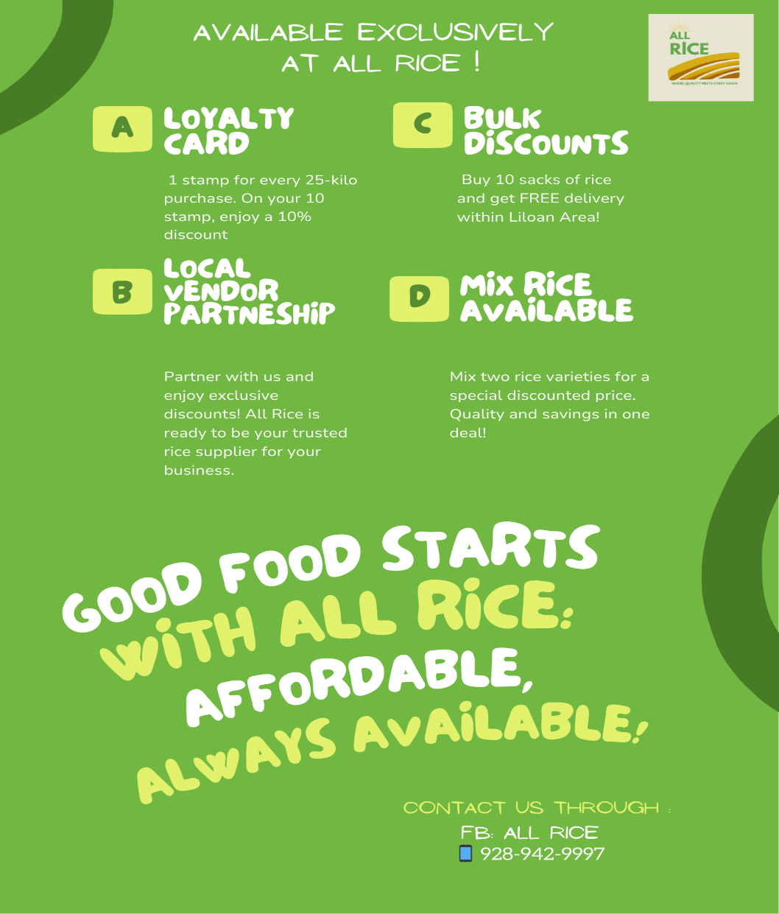In addition to digital marketing efforts, printed materials play a crucial role in promoting All Rice, particularly through the use of flyers. Flyers are a versatile and impactful tool, valued for their visual appeal and cost-effective, straightforward production process. Distributing flyers effectively captures the attention of potential customers, enhancing brand visibility. To ensure maximum impact, flyers will be printed on A7 paper (74x104mm), offering a compact and visually appealing design. The layout, content, and aesthetics have been meticulously planned to clearly convey the brand message and showcase rice products.

**Figure 1.2** *Flyers*

**All Rice Loyalty Card**

The All Rice Loyalty Card is a strategic customer retention tool designed to foster repeat purchases and strengthen customer loyalty. By offering attractive rewards and incentives, the loyalty card enhances customer engagement while promoting long-term brand commitment. The sleek, user-friendly design ensures convenience, while the straightforward reward system motivates continued patronage. Customers receive one stamp for every 25-kilo rice purchase, and upon collecting the 10th stamp, they are rewarded with a 10% discount. This simple yet impactful approach consistently encourages customers to choose All Rice for their needs.



**Figure 1.3** *Loyalty Card*

**All Rice Facebook Page**

The All Rice Facebook page serves as a dynamic platform to connect with customers, share updates, and promote rice products. Regular posts include promotions, product announcements, and community engagement content, fostering interaction and brand loyalty. The page also serves as a customer support channel, allowing inquiries and feedback through direct messages or comments. By maintaining an active and engaging presence, the All Rice Facebook page strengthens customer relationships and increases brand visibility.



**Figure 1.4** *Facebook Page*

**MANAGEMENT ASPECT**

**Chapter 2**

**Management Study**

**INTRODUCTION**

The Management Aspect of this feasibility study focuses on evaluating how All Rice will be managed to ensure smooth operations and long-term success. This section outlines the organizational structure, roles and responsibilities, staffing requirements, decision-making process, legal compliance, and risk management strategies that will guide the daily operations of the business. By carefully planning these aspects, All Rice aims to create an organized, efficient, and adaptable management system that fits the nature of a small rice retail business.

Strong management systems are crucial for businesses in highly competitive industries like rice retailing. This is because success depends not only on having a quality product but also on efficient store operations, customer satisfaction, and effective cost control. The owner’s leadership style, combined with clear processes for handling employees, suppliers, and customers, will directly affect how well the business performs. All Rice recognizes that good management is the backbone of consistent service, good product availability, and customer loyalty.

The management plan for All Rice is designed to be practical and realistic, considering the size and scale of the business. By having a hands-on owner-manager, clear task assignments for employees, and simple but reliable systems for tracking sales, inventory, and performance, the business will be able to operate efficiently while remaining flexible to market changes and customer needs. This well-rounded approach to management creates a strong foundation for both day-to-day operations and long-term business growth.

**NAME AND NATURE OF THE BUSINESS**

The agreed proposed business name is "All Rice", conveys expertise and specialization, reinforcing trust among customers. The name carries a deeper meaning by subtly incorporating the concept of "rise", symbolizing growth, progress, and prosperity in the rice industry. It reflects the advancement of local farmers, the improvement of rice quality, and the development of the rice sector in the Philippines. Ultimately, it stands as a symbol of empowerment, innovation, and a thriving future for the industry.

All Rice is a rice retail business dedicated to providing high-quality, affordable, and accessible rice to households, small businesses, and bulk buyers. The store offers a variety of rice types to meet different customer needs, ensuring a consistent and reliable supply. Strategically located in a high-traffic area, All Rice prioritizes customer convenience and satisfaction through excellent service and well-maintained inventory. By establishing strong relationships with trusted suppliers, the business ensures competitive pricing and product availability, making it a go-to rice retailer in the community.

**PROPOSED LEGAL STRUCTURE**

All Rice will adopt a Sole Proprietorship business type of business, which is the most suitable structure for a rice retail business. This setup offers simple registration procedures, lower operational costs, and complete decision-making authority under the owner. In a rice retail store, decisions such as adjusting prices, selecting suppliers, and handling customer requests must be made quickly. With a sole proprietorship, the owner can immediately respond to these situations without going through complicated approval processes. This fast decision-making helps the business stay competitive and responsive to customer needs.

This also fits well with All Rice’s operational size. The store will be managed directly by the owner, supported by a small team. With this lean setup, the business can minimize expenses while maintaining close supervision over product quality, inventory, and customer service. This simple structure allows for efficient communication and smooth coordination among team members, ensuring daily operations run efficiently.

Since All Rice aims to serve a local community, the sole proprietorship model allows the owner to build personal relationships with customers. This personalized service approach helps create trust and loyalty, which are essential for small retail businesses. By combining hands-on leadership with a clear and direct management structure, All Rice can ensure that both operational efficiency and customer satisfaction are achieved.

**BUSINESS LOGO**



**Figure 2.0***Business Logo*

The All Rice logo reflects the brand’s commitment to quality, sustainability, and agricultural progress. The golden fields symbolize fertile land and a bountiful harvest, while the sun represents growth, prosperity, and hope. The upward arrow in "RICE" subtly incorporates the concept of "rise" which signifies progress and innovation in the rice industry. Its color palette reinforces these values—golden yellow for abundance, light green for growth and sustainability, and brown for fertile soil and agriculture. The tagline, "Taste of Home in every grain," underscores the brand’s dedication to providing premium, high-quality rice with excellence and consistency. It also suggests comfort and connection—bringing people together through every meal.

**VISION**

To be the most trusted and customer-preferred rice retailer, offering high-quality and affordable rice while ensuring convenience, reliability, and excellent service.

**MISSION**

* **Premium Quality-** Committed to offering high-quality rice at competitive prices.
* **Excellent Customer Service-** Providing responsive and friendly service to meet customer needs.
* **Community Presence** Striving to be the go-to rice retailer by prioritizing quality, affordability, and convenience.
* **Strong Supplier Relationships** – Build and maintain partnerships with trusted suppliers for quality assurance and steady inventory.

**CORE VALUES**

* **Sustainability** – Supporting eco-friendly and responsible rice sourcing and distribution.
* **Integrity & Trust** – Maintaining honesty and transparency in all business operations.
* **Innovation & Growth** – Continuously improving and expanding to serve evolving market needs.
* **Economic Responsibility** – Contributing to food security and economic stability through fair pricing and ethical business practices.
* **Community Engagement** – Foster trust and loyalty within the community by engaging with customers and understanding their needs.

**GOALS**

* **Consistent Product Availability** – Ensure a stable and reliable supply of high-quality rice to meet customer demand.
* **Customer Satisfaction** – Provide excellent service, maintaining a welcoming and efficient shopping experience.
* **Operational Efficiency** – Streamline store management, inventory handling, and sales processes for smooth operations.
* Health Standards- To provide safe and clean food for every customer, to ensure the restaurant is maintaining health code standards
* **Business Growth** – Expand retail operations by opening additional locations or increasing product variety to serve more customers.

**ORGANIZATIONAL FLOW CHART**

An Organizational Flow Chart is a visual representation of a company’s structure, showing the hierarchy, roles, and relationships between different positions and departments. It helps illustrate how communication and decision-making processes flow within the organization. This chart helps improve efficiency, clarify responsibilities, and ensure a smooth workflow within the business.

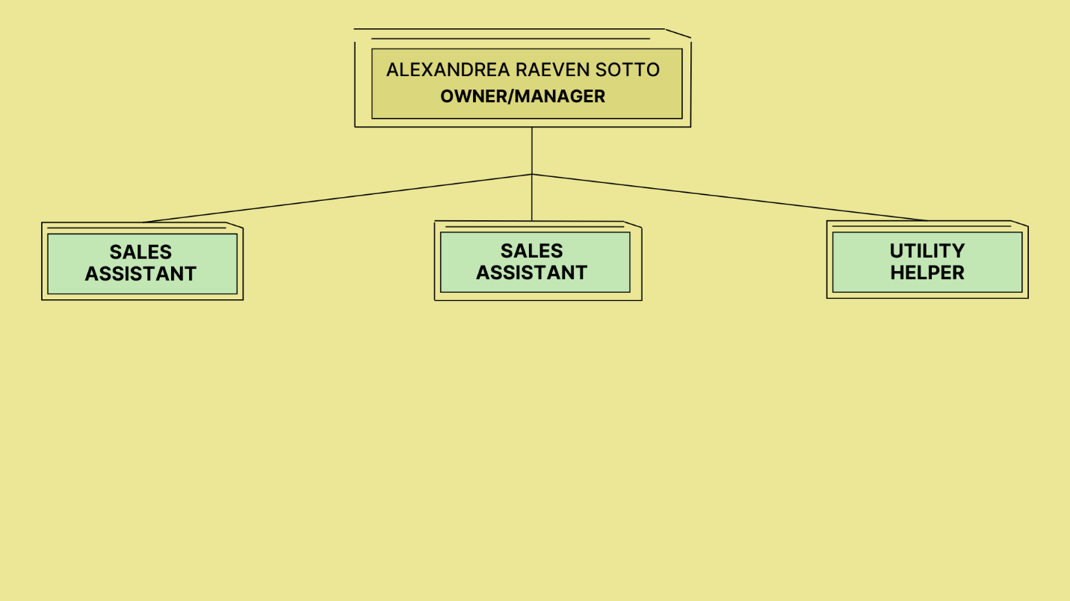

***Figure 2.1****Organizational Flow Chart*

**STAFFING PLAN AND RESPONSIBILITIES**

A Staffing Plan and Responsibilities defines the essential workforce structure of a business, specifying the required positions, number of employees, and their respective duties. It serves as a strategic framework to ensure that qualified individuals are assigned to appropriate roles, enhancing operational efficiency, productivity, and overall business effectiveness.

All Rice will need a small yet efficient team to ensure the smooth operation of the rice retail store. The core team will include a store manager/owner, sales assistant, a cashier, an inventory handler, and a utility helper.

***Table 2.0 Management Personnel***

|  |  |
| --- | --- |
| **Position** | **Number of Staff** |
| Owner/Store Manager | 1 |
| Sales Assistant | 2 |
| Utility Helper | 1 |

**JOB ANALYSIS**

Job analysis is the process of gathering and documenting essential details about a specific job. It helps in understanding the tasks, responsibilities, and requirements associated with the role. This process involves identifying the duties performed, the skills and knowledge needed, and the abilities required for successful job performance. Job analysis consists of two key components: job description and job specification. Establishing clear qualifications and criteria ensures the selection of the right individuals, forming a strong foundation for effective recruitment. A job description provides an overview of the role, outlining its key responsibilities, whereas a job specification details the qualifications, skills, and attributes an individual must possess to be eligible for the position.

***Table 2.1 Job Specification and Description for Manager***

|  |  |
| --- | --- |
| **OWNER / STORE MANAGER** | |
| **Job description** | **Job Qualification** |
| Oversee and manage store operations, including sales, inventory, and customer service | Bachelor’s degree in Business Administration, Management, or a related field (preferred but not required). |
| Supervise and train employees, ensuring performance and service standards are met. | Strong leadership and decision-making skills to manage operations and employees effectively. |
| Maintain accurate sales and financial records, track expenses, and prepare reports. | Excellent communication and interpersonal skills for staff coordination and customer service. |
| Build and maintain strong relationships with suppliers for quality product sourcing. | Knowledge of inventory management, sales tracking, and basic financial reporting. |
| Receive and verify deliveries, ensuring accurate stock quantities | Proficiency in Google Sheets/Excel for record-keeping and reporting |
| Ensure compliance with company policies, labor regulations, and food safety standards. | Strong problem-solving abilities and the ability to work in a fast-paced retail environment. |
| Monitor market trends and competitor activities to adjust pricing and marketing strategies | Must be detail-oriented, organized, and proactive in handling store challenges. |

***Table 2.2 Job Specification and Description for Store Assistant***

|  |  |
| --- | --- |
| **SALES ASSISTANT** | |
| **Job description** | **Job Qualification** |
| Assist customers with inquiries, provide product information, and help with selection. | Strong customer service skills and ability to communicate effectively. |
| Restock shelves, arrange product displays, ensure store organization, and support marketing efforts such as promotions | Basic math and proficiency in Google Sheets/Excel |
| Issue receipts, remit cash to the store manager, and balance daily sales reports and ensure proper documentation. | Ability to work in a fast-paced environment and can multitask |
| Monitor product availability and report low stock to the inventory handler or store manager. | Ability to follow instructions and handle physical tasks. |
| Handle cash and card transactions, ensuring accuracy and efficiency. | Attention to detail and willingness to learn. |

***Table 2.3 Job Specification and Description for Utility Helper***

|  |  |
| --- | --- |
| **UTILITY  HELPER** | |
| **Job description** | **Job Qualification** |
| Ensure proper storage and handling of products to maintain quality. | Male |
| Assist in unloading and storing supplies | No formal education required but must be physically fit and capable of lifting heavy items. |
| Handle waste disposal and ensure proper maintenance of store facilities. | Willingness to do manual labor and deliver goods to customers |
| Support other staff with errands and must be skilled in driving for deliveries. | Ability to follow instructions and work independently. |
| Monitor stock levels, record inventory, and report shortages. | Strong customer service skills and ability to communicate effectively. |

**RECRUITMENT STRATEGY**

All Rice will implement a community-based recruitment approach to attract suitable candidates. Job vacancies will be posted at the barangay hall, shared in local social media groups, and announced through word-of-mouth referrals from trusted community members. This strategy not only reduces recruitment costs but also helps identify candidates who are familiar with the community and the store’s potential customers.

Applicants will undergo a simple screening and interview process conducted by the owner. The assessment will focus on communication skills, customer-friendly attitude, and reliability. Previous retail experience is a plus but not required, as training will be provided. By hiring locally, All Rice also contributes to local employment opportunities, strengthening its community ties.

The following are the steps must be followed in hiring applications;

* Applicants must submit their resume / biodata with a 2x2 picture on it.
* The owner/manager will assess all applications and select those suitable for the position
* The applicant will be called for an interview, if the applicant will pass the interview he/she will be given a list of requirements for the job and offer a letter with salary details and job responsibilities.
* The newly hired employee will be trained before he/she can start the job.
* The new employee’s performance will be under probation to ensure they meet expectations and fit well within the organization.

**Pre-Employment Requirements**

* At least High School or Senior High School Graduate
* Resume / Biodata
* 2x2 picture

**Post-Employment Requirements**

* PSA Birth Certificate
* Medical Certificate
* NBI or Police Clearance
* Barangay Clearance
* Philippine Health Insurance Corporation (PhilHealth)
* Social Security System (SSS)
* Pag-IBIG

**TRAINING AND DEVELOPMENT**

Training and Development is a process in every business organization which enhances the performance of a newly hired employee. Training educates the new employees to know what they will do for their job and enhance their skills. It also includes how they treat the customers in the right way which will also help the company improve and gain more customers.

**Training Courses for the Newly Hired Employees:**

* **Orientation**

Most companies provide orientation for newly hired employees to help them become organized in their roles. Orientation introduces them to the company's rules and regulations while also welcoming them and familiarizing them with the business. Additionally, all employees will participate in a structured onboarding program before officially starting their work. This training will cover:

- Product knowledge (rice varieties, quality indicators, proper storage)

- Customer service standards (greeting, assisting, handling inquiries)

- Sales procedures (weighing, pricing, recording transactions)

- Basic inventory processes (restocking, updating records)

- Cleanliness and sanitation practices

* **Food Safety / Proper Storage**

Ensuring food safety is a top priority in a retail rice business to maintain product quality and protect consumer health. We adhere to strict food safety practices, starting with proper rice storage in a clean, dry, and well-ventilated area to prevent moisture buildup and contamination. Rice is kept off the ground using pallets, and exposure to direct sunlight or extreme temperatures is avoided to maintain freshness.

* **Quarterly Refresher Training**

Beyond initial training, All Rice will conduct quarterly refresher training to update employees on any changes in product offerings, pricing adjustments, and customer service improvements. Employees will also receive on-the-job coaching from the owner to reinforce skills and correct any errors. This continuous development process ensures staff maintain high service standards and operate efficiently.  
  
**Gaps in Expertise**

Despite the strengths of the management team, there are some identified gaps in expertise that need to be addressed to further enhance the efficiency and competitiveness of All Rice.

**Primary Gaps**

1. Digital marketing, particularly in the effective use of social media platforms. While the owner recognizes the importance of maintaining an online presence to attract and engage customers, there is limited knowledge in creating professional marketing content, scheduling posts, and using social media insights to analyze customer behavior. To address this, the owner plans to enroll in basic digital marketing courses, focusing on social media management for small businesses.
2. Limited proficiency in using Excel for advanced inventory tracking and financial reporting. Although the owner is capable of basic data entry, there is a lack of technical knowledge in creating automated reports, using formulas for sales analysis, and generating useful charts and graphs. As All Rice plans to rely on Google Sheets or Excel for inventory and sales monitoring, developing stronger Excel skills is essential to enhance efficiency, accuracy, and decision-making based on real-time data. The owner intends to attend short training sessions or workshops to gain a more advanced understanding of Excel functions relevant to retail management.

By actively addressing these gaps, All Rice’s management team will be better equipped to improve its online presence, strengthen its inventory monitoring, and enhance financial reporting, all of which are essential for maintaining operational efficiency and supporting future business growth.

**WORK SCHEDULE**The number of days and hours that the employees are expected to be on the job and working is stated here:

                                                            **Table 2.5** *Work Schedule*

|  |  |  |  |  |  |  |  |
| --- | --- | --- | --- | --- | --- | --- | --- |
| **EMPLOYEE** | **MON** | **TUES** | **WED** | **THURS** | **FRI** | **SAT** | **SUN** |
| MANAGER | 9:00 AM  to  7:00 PM | 9:00 AM  to  7:00 PM | 6:00 AM  to  4:00 PM | 9:00 AM  to  7:00 PM | 10:00 AM  to  8:00 PM | 10:00 AM  to  8:00 PM | Day  Off |
| SALES ASSISTANT (1) | 6:00AM  to  4:00 PM | 6:00AM  to  4:00 PM | Day  Off | 6:00AM  to  4:00 PM | 6:00AM  to  4:00 PM | 6:00AM  to  4:00 PM | 6:00AM  to  4:00 PM |
| SALES ASSISTANT (2) | 10:00 AM  to  8:00 PM | 10:00 AM  to  8:00 PM | 10:00 AM  to  8:00 PM | 10:00 AM  to  8:00 PM | Day  Off | 10:00 AM  to  8:00 PM | 10:00 AM  to  8:00 PM |
| UTILITY HELPER | 8:00 AM  to  6:00 PM | 8:00 AM  to  6:00 PM | 8:00 AM  to  6:00 PM | Day  Off | 8:00 AM  to  6:00 PM | 8:00 AM  to  6:00 PM | 8:00 AM  to  6:00 PM |

**LEGAL AND REGULATORY CONSIDERATIONS**

Legal and regulatory considerations refer to the mandatory requirements that businesses must follow to operate lawfully and ethically. These include securing business permits, licenses, tax registrations, and complying with safety, labor, and environmental regulations. Adhering to these rules helps prevent legal issues, builds credibility, and ensures smooth day-to-day operations.

**Compensation and Employment Benefits**

Compensation and employment benefits refer to the combined package that employees receive in return for their work, encompassing both monetary rewards and additional perks. Compensation includes salaries, wages, bonuses, and commissions, reflecting the direct payment for the tasks performed. Employment benefits, on the other hand, enhance this by offering non-monetary advantages such SSS, incentives and other allowances aimed at supporting employees' well-being and financial security. Together, they form a holistic system designed to attract, motivate, and retain employees while improving their overall job satisfaction and quality of life.

**Salaries and Wages**

All Rice has implemented a structured payroll system to ensure employees receive their salaries on time. Salaries and wages are the financial compensation businesses provide to employees in exchange for their work. To retain qualified and loyal staff, All Rice will promote a positive and supportive workplace culture. Employees will receive fair and competitive wages based on industry standards and business capacity. Additionally, All Rice will provide a monthly reward of 5 kilos of rice as an incentive for employees' hard work and dedication. Employees can also earn incentives for maintaining perfect attendance, ensuring that compensation remains attractive and sustainable.

**Salary Schedule**

The salary of the employees shall be given twice a month, every 5th and 20th day of the month. If ever the pay falls on sunday the salary will be given the day after the said date. To streamline this process, payroll cut-off dates are set on the 15th and 30th of each month. Employees must submit all necessary payroll documents, such as timesheets and leave requests, on or before these deadlines to be included in the upcoming payroll cycle. The releasing of employee’s salaries is done by the owner and should be paid directly to the employee in cash or through the bank.

**13th Month Pay**

All regular employees are legally entitled to a 13th month's compensation, which is equal to one-twelfth (1/12) of the total basic wage earned in a calendar year. Twelve percent (1/12) of the total basic wage an employee receives in a given calendar year should be the minimum amount of their thirteenth month's compensation.

**Government Mandated Benefits**

Partners and employees are entitled to certain benefits such as SSS (Social Security System), Pag-IBIG (Home Development Mutual Fund), PhilHealth (Philippine Health Insurance Corporation), and 13th-month pay. These benefits provide financial assistance and security to employees and their dependents, including health and medical coverage, retirement benefits, and housing loans

**Table 2.6** *Salaries and Wages*

|  |  |  |  |  |  |
| --- | --- | --- | --- | --- | --- |
| **EMPLOYEE** | **RATE PER DAY** | **SECOND WEEK** | **MONTHLY** | **ANNUALLY** | **13TH MONTH** |
| Sales Assistant | 350 | 4,550 | 9,100 | 109,200 | 9,100 |
| Sales Assistant | 350 | 4,550 | 9,100 | 109,200 | 9,100 |
| Utility Helper | 350 | 4,550 | 9,100 | 109,200 | 9,100 |

Table 2.7 SSS, PhilHealth, and Pag-IBIG Contributions

|  |  |  |  |  |  |  |
| --- | --- | --- | --- | --- | --- | --- |
| EMPLOYEE | GOV’T BENEFITS | MONTHLY RATE | EMPLOYER CONT | EMPLOYEE CONT | TOTAL CONT. | ANNUAL  CONT. |
| Sales Assistant | SSS | 9,100 | 910 | 455 | 1365 | 16380 |
| Sales Assistant | PhilHealth | 9,100 | 250 | 250 | 500 | 6000 |
| Utility Helper | Pag-IBIG | 9,100 | 182 | 182 | 364 | 4368 |

**Attendance**

1. Unauthorized absences or absence without official leave (AWOL) are absences from work without prior approval or notification, shall be considered as without pay. Unauthorized extension of an approved leave shall also be charged as AWOL. Unauthorized absences shall be a basis for the imposition of disciplinary action.
2. Employees are required to log-in to the biometric. An employee who fails to file attendance should ask the owners / managers approval to confirm, otherwise it shall be considered as AWOL. Failure to file attendance properly shall merit the employee a disciplinary action.
3. An employee is considered tardy when he reports for work after the start of his official work hours or shift schedule.

* All instances of tardiness regardless of number of minutes shall be monitored and shall be made the basis for possible salary deductions and/or imposition of disciplinary action.
* A 10-minute grace period will be given to each employee.
* An employee who accumulates more than 60 minutes of tardiness within a month or a year, whichever comes first, shall immediately be issued a written warning.
* Corresponding per minute deductions will be made against the employee’s salary for tardiness.

1. Undertime means leaving early or leaving before the end of the employee’s work schedule.

* All instances of undertime regardless of number of minutes shall be monitored and shall be made the basis for possible salary deductions and/or imposition of disciplinary action.
* Corresponding per minute deductions are made against the employee’s salary for undertime.

1. Overtime means employees working beyond regular working hours with prior approval will be compensated accordingly. Overtime pay rates will follow company policies to ensure fair compensation for extra work hours.
2. As the business grows, All Rice will also offer opportunities for promotion, particularly for long-serving employees who demonstrate leadership potential. By combining fair compensation, regular recognition, professional development, and growth opportunities, All Rice aims to foster a loyal, motivated, and skilled workforce.

**PERFORMANCE APPRAISAL**

A performance appraisal is a formal evaluation process used to systematically assess an employee's job performance and overall contribution to the organization's objectives. Typically conducted on an annual basis, it provides a structured framework for identifying employee strengths, addressing areas for improvement, and aligning individual performance with business goals. Performance appraisals serve as a basis for key decisions regarding salary adjustments, promotions, incentives, and professional development opportunities.

Each employee is evaluated annually by these criteria:

***Table 2.8*** *Criteria*

|  |  |
| --- | --- |
| **Criteria** | **Grade** |
| Attendance and punctuality | 20 % |
| Initiative | 15% |
| Being productive and hardworking at work | 15% |
| Work Quality | 25% |
| Customer Service | 25% |
| **Total** | **100%** |

**Rules and Regulations**

To maintain order, professionalism, and efficiency, All Rice will implement the following rules and regulations for all employees:  
  
**Workplace Conduct**

* Employees must report to work on time and adhere to their assigned schedules.
* Professionalism and respectful behavior must be observed at all times.
* Personal phone use during working hours should be minimized except for emergencies.
* Theft, dishonesty, or any form of misconduct will result in disciplinary action.

**Uniform and Identification**

* Employees must wear the designated uniform and ID at all times for easy identification and professionalism.
* Uniforms should be clean and well-maintained to uphold a presentable appearance.

**Customer Service**

* Employees must provide courteous and efficient service to all customers.
* Complaints or issues should be reported immediately to the owner or manager.

**Store Maintenance and Safety**

* Workstations must be clean and organized at all times.
* Proper handling and storage of rice products must be followed to maintain quality.
* Employees must comply with safety protocols to prevent accidents and hazards.

**Compliance and Accountability**

* Employees must follow company policies and guidelines at all times.
* Absences or tardiness must be reported in advance with a valid reason.
* Violations of store policies will result in appropriate disciplinary action.

**Utilization of Study Materials and Resources**

* All Rice resources should only be used for business purposes.
* Any damage to store equipment or resources should be reported as soon as possible.

**Termination and Sanctions**

Employees who violate business policies must face the consequences of their actions. It ensures accountability and upholds the integrity of the workplace. It is essential to maintain a professional and respectful environment for all.

***Table 2.9 Termination and Sanctions***

|  |  |
| --- | --- |
| **Serious Offenses and Violations** | **Sanctions** |
| Theft or Misappropriation of Funds | **First Offense:** Issue a verbal warning requiring reimbursement of the misappropriated funds.  **Second Offense:** Deliver a written warning and impose a suspension.  **Third Offense:** Terminate employment. |
| Discrimination and Violence toward customers or Colleagues | **First Offense:** Provide a written warning and mandate participation in a counseling session to correct behavior.  **Second Offense:** Escalate to a final written warning.  **Third Offense:** Terminate Employment |
| Intoxication on Duty | **First Offense:** Give a verbal warning and immediately remove the individual from their duties.  **Second Offense:** Issue a written warning and require attendance in an alcohol abuse counseling program.  **Third Offense:** Terminate employment and suggest enrollment in addiction treatment programs. |
| Damage to Property | **First Offense:** Administer a written warning and demand compensation for the damages.  **Second Offense:** Provide a final written warning and consider additional disciplinary measures.  **Third Offense:** Terminate employment. |
| Repeated Absenteeism or Tardiness | **First Offense:** Offer a verbal warning and advise on the importance of timeliness.  **Second Offense:** Issue a written warning and seriously discuss it with management, possibly leading to decreased shifts or responsibilities.  **Third Offense:** Present a final written warning, with termination as a potential outcome if the behavior does not improve. |

**Licensing & Permits**

To ensure legal and compliant operations, All Rice will obtain all necessary permits and licenses, including:

• **Barangay Clearance** – Issued by the barangay where the business is located, certifying compliance with local community regulations.

• **DTI Business Name Registration** – Provides legal protection for the business name and validates its legitimacy as a sole proprietorship.

• **Business Permit / Mayor’s Permit** – Issued by the Liloan Municipal Hall, this authorizes business operations within the municipality.

• **BIR Certificate of Registration (COR)** – Ensures tax compliance and authorizes the business to issue official receipts.

• **Sanitary Permit** – Issued by the Municipal Health Office, this ensures that the store complies with public health and sanitation standards.

• **Health Certificate** – Required for the business owner and any staff, certifying they are medically fit to handle food products like rice.

• **NFA License** – Required by the National Food Authority (NFA) for all rice retailers and dealers, ensuring proper handling and sale of rice.

• **Fire Safety Inspection Certificate** – Issued by the Bureau of Fire Protection (BFP), confirming compliance with fire safety standards.

• **Building Permit/Renovation Permit** – Required for any structural modifications, ensuring compliance with zoning, construction, and safety regulations.

• **SSS, PhilHealth, and Pag-IBIG Registration** – If the business hires employees, it will register with these government agencies to provide mandatory benefits and ensure labor law compliance.

• **BMBE Certificate of Authority** – To avail of tax incentives and government support for small businesses under the Barangay Micro Business Enterprise (BMBE) Law.

By securing these permits, All Rice demonstrates commitment to legal compliance, operational integrity, and ethical business practices, fostering trust among customers, suppliers, and regulatory authorities.

**DECISION-MAKING PROCESSES**

The decision-making process refers to the systematic approach used to evaluate options and make choices that guide business operations and strategies. It involves identifying a problem or opportunity, gathering relevant information, analyzing possible solutions, selecting the best course of action, implementing the decision, and reviewing its effectiveness.

**Governance Structure**

All Rice will follow a centralized decision-making structure, where the owner holds full authority in making key business decisions. As the sole proprietor, the owner will manage major decisions such as product pricing, supplier selection, promotions, budgeting, and business expansion. This centralized governance ensures that decisions are made quickly, which is critical for adapting to price changes, supply issues, and customer demands. Having a single decision-maker also allows the business to respond immediately to operational challenges without waiting for approvals from multiple levels. While strategic decisions remain with the owner, employees are encouraged to provide input on customer feedback, inventory flow, and operations. Regular meetings foster open communication and continuous improvement.

**Delegation of Authority**

In terms of delegation of authority, the owner may delegate routine tasks such as inventory checking, cashier duties, and basic customer service to store assistants, but strategic decisions will always remain under the owner’s control. This combination of centralized leadership and delegated operational duties ensures that All Rice remains organized, responsive, and accountable, while empowering employees to handle their day-to-day responsibilities confidently.

**RISK MANAGEMENT STRATEGIES**

Risk management strategies are structured approaches used to identify, assess, and minimize potential risks that may impact operations, financial stability, or overall business performance. These strategies help ensure business continuity, efficiency, and resilience by implementing proactive measures to address uncertainties. Through preventive and adaptive measures, businesses can mitigate risks, maintain stability, and support long-term growth.

**Potential Risk**

* **Supply Disruptions** – All Rice recognizes that delivery issues from suppliers can lead to stock shortages, affecting operations and customer satisfaction. To prevent this, the business will establish relationships with multiple suppliers, ensuring a backup source is available if one experiences delays or shortages.
* **Employee Absences and Turnover** – Unexpected staff absences or resignations can disrupt store operations. To address this, All Rice will implement cross-training, enabling employees to handle multiple roles, such as sales, customer service, and inventory management. This flexibility ensures smooth operations even when a staff member is unavailable.
* **Price Fluctuations** – Rice prices can change due to seasonal shortages or economic conditions, impacting profitability. To manage this risk, All Rice will maintain a buffer stock of high-demand rice varieties, especially before peak seasons, and set aside an emergency fund to handle sudden price hikes or operational expenses.
* **Performance Monitoring** – Regular employee performance reviews will be conducted to assess engagement and identify issues before they affect store operations. This proactive approach ensures staff remain motivated and operational efficiency is maintained.

**TECHNOLOGY AND INFORMATION SYSTEM**

Technology and Information Systems refer to the tools and processes used to manage business operations efficiently. They help streamline sales tracking, inventory management, customer communication, and financial monitoring by ensuring accurate record-keeping and automation. These systems improve productivity, reduce errors, and enhance decision-making, allowing businesses to operate smoothly and adapt to market demands.

**Sales and Inventory Management**

* Daily transactions will be recorded in a manual sales logbook during operating hours.
* Sales data will be entered into a Google Sheet or Excel file at the end of each day for digital record-keeping.
* This combination of manual and digital records ensures accuracy, organization, and easy review of sales data.

**Inventory Tracking and Insights**

* The Google Sheets or Excel system will track rice type, quantity sold, selling prices, and total daily sales.
* Inventory levels will be automatically adjusted based on deliveries and sales transactions.
* Regular record reviews will help identify fast-moving products, promotional needs, and restocking schedules.
* This cost-effective and user-friendly system eliminates the need for expensive inventory software.

**Customer Connection**

* All Rice will maintain active communication channels through social media and a dedicated phone line.
* The store’s Facebook page will be used for promotions, product updates, and announcements.
* Customers can call or text for inquiries, bulk orders, and delivery requests.
* This multi-channel approach improves customer accessibility, engagement, and satisfaction.

**Communication Strategies**

Effective communication is essential to All Rice’s operations, both internally and externally. This refers to the planned methods and approaches used to exchange information effectively within a business. These strategies ensure clear, timely, and efficient communication between employees, management, suppliers, and customers. Strong communication strategies help businesses streamline operations, improve teamwork, enhance customer relationships, and maintain smooth coordination.

* Internally, daily briefings will be held before the store opens to review the day’s tasks, expected deliveries, and any special customer requests. This ensures that all staff members are aligned on responsibilities and aware of any issues that need attention. Daily briefings help keep operations smooth and organized.
* Once a week, All Rice will also conduct weekly performance meetings, where the owner and staff will review sales performance, check inventory levels, and discuss customer feedback. This allows the owner to gather valuable insights directly from the team, especially on customer preferences, complaints, or requests. By encouraging open communication, All Rice creates a collaborative environment where employees feel valued and heard.
* Externally, All Rice will maintain regular communication with suppliers to confirm delivery schedules, check for any price changes, and ensure product quality. For customers, All Rice will actively update its social media pages and respond promptly to messages and inquiries. Customers can also call or text the store’s dedicated phone number for quick questions, bulk orders, or special requests. By offering multiple ways to communicate, All Rice makes it easy for customers to stay connected, enhancing customer satisfaction and loyalty.

**FINANCIAL OVERSIGHT IN MANAGEMENT**

All Rice will ensure that its finances are handled with care, accuracy, and transparency. The owner will be responsible for all financial transactions, including purchases, sales, and operating expenses. Each sale will be recorded in the manual sales logbook during business hours, and at the end of the day, these records will be transferred to the Google Sheets or Excel file. This process ensures that all transactions are documented twice, making it easier to detect errors or missing entries and maintain complete financial records.

In addition to sales tracking, all inventory purchases will be carefully recorded, ensuring that stock levels match sales performance. By analyzing inventory flow alongside sales data, the owner can make smart purchasing decisions, avoiding unnecessary overstock while ensuring that fast-moving rice varieties are always available. This close monitoring of inventory and expenses helps control costs while keeping the store well-stocked.

Every month, All Rice will conduct a detailed financial review, where the owner will evaluate total sales, operating expenses, profit margins, and inventory turnover. This regular review allows the owner to identify trends and areas for improvement, such as adjusting prices, adding promotions, or negotiating better rates with suppliers. To ensure the store can handle unexpected financial challenges, All Rice will also maintain a separate emergency fund for sudden price increases, repairs, or other unforeseen expenses. These regular financial reviews ensure that All Rice stays financially sound and competitive.

**UNIFORM & ID**

Wearing a uniform and ID is essential for maintaining professionalism, security, and brand identity in the workplace. Uniforms create a consistent and professional appearance, helping customers easily recognize employees while promoting the company’s brand. They also foster team unity and ensure that staff adhere to dress code standards.

Meanwhile, ID cards enhance security and accountability, ensuring that only authorized personnel have access to business premises. IDs also help customers easily identify staff members, improving customer service and trust. By implementing uniforms and IDs, businesses promote a professional, secure, and organized work environment.

**TECHNICAL ASPECT**

**Chapter 3**

**Technical Study**

The technical aspect of All Rice focuses on the processes, equipment, and strategies essential for efficient rice distribution and customer satisfaction. It involves evaluating the methods of sourcing, storing, packaging, and delivering rice to ensure quality and consistency. This aspect is crucial in establishing a streamlined operation that meets the demands of consumers while maintaining high product standards.

To achieve operational efficiency, All Rice implements best practices in rice handling and storage, utilizing appropriate equipment to preserve freshness and quality. The packaging process is designed to maintain product integrity, while logistics and delivery systems are optimized for timely distribution. Additionally, quality control measures are in place to ensure that every batch of rice meets the brand’s standards before reaching the market.

By focusing on technical efficiency, All Rice aims to build a reliable supply chain that caters to the diverse needs of customers. Integrating technology and innovative practices enables better inventory management, consistent product quality, and effective customer service. This structured approach supports the company’s goal of delivering high-quality rice products while building long-term customer loyalty.

**Product**

All Rice is a retail business that offers a broad variety of rice and these are the various types of rice offered and the description they have.

**Table 3.0** *List of varieties offered*

|  |  |  |
| --- | --- | --- |
| **Products** | **PRODUCT VARIETY** | **DESCRIPTION** |
| https://lh7-rt.googleusercontent.com/docsz/AD_4nXcpYmHHq4xOkTtT6eG9DeMrlc6_8-y7cGCLi8A9jnqsA6cekJbHdazgDA9TQtYMYE_VaLqUlIkmN84L2wjKo6de0Bgt6IIfLjjSP03ucW99rIVz6eSDtVI_2DUJqwcCAQ1fPbi4?key=GGt0KK3Ali6R5vT63MbpQ5iJ | IVORY | Lion Ivory Grains Classic Premium Rice Grown and harvested in the best trade of Cagayan valley, carefully selected crop with finest grains and processed using the latest technology. |
| https://lh7-rt.googleusercontent.com/docsz/AD_4nXeKAUGn6RvBVLSIGsmCRt1J3JBGcMPgS6GVbrbm43XynKmAyR_WMUdE9Kx_HEd9M7KUi5RdSp_aVOd4GpZZvXooM93_NvbZmppZ7CGbOiyIg-tE9XvDBf1UFAuUjsSR14nR7TmCDg?key=GGt0KK3Ali6R5vT63MbpQ5iJ | GANADOR | Ganador is locally grown and produced in Nueva Ecija. But it is already a hybrid rice classified as IR64 rice, which means it is genetically mutated to produce a very good quality of grains in a specific environment/weather. IR64 is the most widely grown rice variety in the tropics like the Philippines. |
| https://lh7-rt.googleusercontent.com/docsz/AD_4nXcQ2VxG5AaZdH0FZI0vqTWY1APPYZnaJnPiiq33rGUrqZhbMq_YYiQBzkhM-ry3c9neN9qpveYWN1YTO0T8dD_s63o6Fy3W1ViPXiXAK7wx9LqvyDFOEQKe2bhjLeYSa0bDkPl7iA?key=GGt0KK3Ali6R5vT63MbpQ5iJ | PRINCESS BEA | Princess Bea rice, often described as a premium, whole-grain rice, is known for being soft, fluffy, and fragrant. It is sometimes referred to as "Princess Bea Red" or "Princess Bea Special Rice". |
| https://lh7-rt.googleusercontent.com/docsz/AD_4nXeVGeQ_DB7CgoBEAxvQ4YqemOQeyiGohE3Kgq_DeWUCKdZh-zvlnTp6MwStNpgBTcQQvikCoh13xxSgPMqK6y27baCZBrdDUGTSF11f3gZsrca489z8av9h53_oCeaW2ivUd_lT?key=GGt0KK3Ali6R5vT63MbpQ5iJ | DOÑA CONCHITA  (blue&orange) | Doña Conchita is a premium quality imported rice from Vietnam with an exquisite blend of stickiness and softness that will exceed expectations. With its captivating aroma, each grain tantalizes the senses, making it perfect for traditional Filipino dishes. |
| https://lh7-rt.googleusercontent.com/docsz/AD_4nXfKJWYQMb7TRjWoxD1107pryJPRpnreqOjNC4dbmpVnbFlYh-LhP_0DrQw42WS3N15fO7oVHYQB0RV1Kg3Jj4J8eQD-n4IHHX2UIkGOqV26gaBoqwirUNFxckt9LuXkpWgbS6PB?key=GGt0KK3Ali6R5vT63MbpQ5iJ | BROWN RICE | This variety is a whole-grain rice that retains its bran layer, rendering it more nutrient-dense compared to white rice. Typically displaying a tan or light brown hue, it serves as the  "unrefined" counterpart to white rice. Due to its composition, it often feels "lighter" in the stomach and may contribute to preventing insulin spikes, facilitating quicker digestion. |
| https://lh7-rt.googleusercontent.com/docsz/AD_4nXexz244-CFf3UYwytkiuGRVycHzcgWBUnnYG-KTGsKp9PTDoARCo2d0uovNHbYEAwIbMEtpdapyyP5Ib1HyVI-TCuPDLi0jV2SETkRFJoWFWgX3d-Vl85_j6rH190AHYYoIs7wa?key=GGt0KK3Ali6R5vT63MbpQ5iJ | CORN  (14&16) | White corn rice, also known as "Bigas Mais," is a popular rice alternative and is a good source of fiber, vitamins, and minerals. It's a good substitute for white rice, especially for those with dietary restrictions or seeking a healthier option. It is known for its lower glycemic index, which can help regulate blood sugar levels, making it suitable for individuals with diabetes or those watching their blood sugar levels. |
| https://lh7-rt.googleusercontent.com/docsz/AD_4nXew29KtfvP690iTaWoRUNfPqWDDRX9371PXZd-zCqo81D7Q1k2WxQxeomyndtNEykfBYNmltsWZTn6uDbCwKWEVivxr4ZE38tl-bK2Xkf0ak2WIg4u6cPSOixcVaj5VntuDl3NVRQ?key=GGt0KK3Ali6R5vT63MbpQ5iJ | GLUTINOUS RICE | Glutinous rice, also known as sticky or sweet rice, is a short-grain rice variety characterized by its sticky, chewy texture when cooked, and is often used in Filipino cuisine for both savory and sweet dishes. Unlike long-grain rice, glutinous rice has a shorter, rounded grain shape. It is generally low in fat and cholesterol |
|  | MIX RICE | **Mix Rice** is a customizable blend of **two different rice varieties**, allowing customers to choose their preferred combination based on taste, texture, and budget. Whether opting for an **equal mix (½ of each variety)** or a **specific ratio (e.g., ¾ of one and ¼ of another),** customers can create a blend that suits their needs. A **list of approved rice varieties** is available. This option provides flexibility, affordability, and a unique rice experience—perfect for households and businesses looking for variety and value. |

**ROUTINE SYSTEM MAINTENANCE**

Routine system maintenance involves regularly checking, cleaning, updating, and repairing equipment, processes, and data systems to ensure smooth and efficient operations. It helps prevent unexpected breakdowns, maintains product quality, and ensures compliance with regulations. By following a routine maintenance plan, businesses can reduce downtime, increase productivity, and maintain a safe and organized working environment. For All Rice, routine system maintenance is essential to ensure accurate record-keeping, proper inventory management, and high-quality customer service.

**1. Daily Tasks:**

* Check and clean the sales logbook and digital records to ensure accuracy.
* Update sales and inventory data on Google Sheets or Excel.
* Backup digital files to an external drive or cloud storage.
* Clean and sanitize the store, including storage areas and display counters.
* Check rice quality and stock levels to ensure freshness and availability.

**2. Weekly Tasks:**

* Perform a thorough inventory check and update stock records.
* Inspect rice storage areas for signs of pests or moisture.
* Clean and disinfect rice bins and weighing scales.
* Review sales performance and customer feedback during weekly meetings.
* Calibrate weighing scales to maintain accuracy.

**3. Monthly Tasks:**

* Conduct a full audit of sales and inventory records.
* Clean and maintain the biometric attendance system.
* Check equipment, such as computers and weighing scales, for any issues.
* Update pricing and product availability on social media pages.
* Provide maintenance to ventilation and pest control systems.

**4. Quarterly Tasks:**

* Perform a detailed equipment inspection and repair or replace damaged items
* Conduct staff training on new procedures or safety protocols.
* Update digital record-keeping systems and improve data management practices.
* Review and update safety and sanitation practices.
* Perform a risk assessment and evaluate compliance with regulations.

**5. Annual Tasks:**

* Conduct a comprehensive business performance review.
* Renew necessary permits and certifications (e.g., Business Permit, Sanitary Permit).
* Update operational policies based on feedback and performance reviews.
* Plan for store upgrades or equipment replacements if needed.
* Perform a full backup of the year's sales and inventory data.

By adhering to this routine maintenance plan, All Rice can ensure smooth operations, maintain product quality, and foster a safe and efficient workplace.

**OPERATIONAL FLOW CHART**

**Figure 3.0** *Business Operation Workflow*

**BUSINESS OPERATION**

The business “All Rice” will operate 14 hours daily, from 6:00 A.M. to 8:00 P.M., seven days a week, ensuring continuous service. To manage operations efficiently, employees will follow a shifting schedule, where some will be assigned to open the store while others will handle the closing. This shift system ensures that employees do not work the full 13-hour period, preventing burnout and maintaining productivity. By having a structured schedule, the business can maximize operational efficiency, provide better customer service, and ensure that there is always adequate staffing throughout the day.

**All Rice Time Schedule**

|  |  |  |  |
| --- | --- | --- | --- |
| **Days in a Week** | **Opening** | **Closing** | **Operating Hours** |
| Monday | 6:00 A.M. | 8:00 P.M. | 14 hrs 00 mins. |
| Tuesday | 6:00 A.M. | 8:00 P.M. | 14 hrs 00 mins. |
| Wednesday | 6:00 A.M. | 8:00 P.M. | 14 hrs 00 mins. |
| Thursday | 6:00 A.M. | 8:00 P.M. | 14 hrs 00 mins. |
| Friday | 6:00 A.M. | 8:00 P.M. | 14 hrs 00 mins. |
| Saturday | 6:00 A.M. | 8:00 P.M. | 14 hrs 00 mins. |
| Sunday | 6:00 A.M. | 8:00 P.M. | 14 hrs 00 mins. |
| **Total Operating Hours Per Week** | | | **98 hrs** |

**STORE SUPPLIES**

|  |  |  |  |  |  |
| --- | --- | --- | --- | --- | --- |
| **Quantity** | **Image** | **Items** | **Suppliers** | **Unit Cost** | **Total Cost** |
| 3 pcs |  | Logbook | People’s Educational Supply | 79.00 | 237.00 |
| 2 pcs |  | Calculator | People’s Educational Supply | 225.00 | 450.00 |
| 5 pcs |  | Cutter | People’s Educational Supply | 30.00 | 150.00 |
| 2 pcs |  | Scissors | People’s Educational Supply | 39.00 | 78.00 |
| 5 pcs |  | Ballpen | People’s Educational Supply | 8.00 | 40.00 |
| 5 pcs |  | HBW Whiteboard Marker | People’s Educational Supply | 40.00 | 200.00 |
| 15 pcs |  | Erasable food price label | Shopee | 11.00 | 165.00 |
| 5 pcs |  | Correction Tape | People’s Educational Supply | 19.00 | 95.00 |
| 10 pcs |  | Plastic - Roll ‘16x24  (125pcs/ pack) | Carbon Public Market | 135.00 | 1,350.00 |
| 5 pcs |  | Plastic Roll ‘14x20  (125pcs/pack) | Carbon Public Market | 150.00 | 750.00 |
| **TOTAL** |  | | | |  |

**Cleaning Supplies**

|  |  |  |  |  |  |
| --- | --- | --- | --- | --- | --- |
| 2 pcs |  | Trash Bin 25L | Unitop | 199.00 | 398.00 |
| 3 pcs |  | Dust pan and broom set | Mr. DIY | 199.00 | 597.00 |
| 3 pcs |  | Trash bag (25pcs per roll) | Mr. DIY | 149.00 | 447.00 |
| 3 pcs |  | Feather Duster | Mr. DIY | 129.00 | 387.00 |
| 10pcs |  | Microfiber Rug | Unitop | 25.00 | 250.00 |
| **TOTAL** |  |  |  |  |  |

**FURNITURE & FIXTURES**

|  |  |  |  |  |  |
| --- | --- | --- | --- | --- | --- |
| **Quantity** | **Image** | **Items** | **Suppliers** | **Unit Cost** | **Total Cost** |
| 3 pcs. |  | Monoblock Chair | Mandaue  Foam | 650.00 | 1,950.00 |
| 2 pcs. |  | Ceiling Fan | Asahi | 2,000.00 | 4,000.00 |
| 2 pcs. |  | Swivel Chair | Mandaue Foam | 1,500.00 | 3,000.00 |
| 1 pc |  | Stand Fan | Mandaue Foam | 999.00 | 999.00 |
| 1pc |  | Office Table | Cebu Home  Builders | 9,000.00 | 9,000.00 |
| 1pc |  | Cashier Table | Cebu Home Builders | 4,000.00 | 4,000.00 |
| 8pcs |  | Tarima | Taboan Public Market | 300.00 | 2,400 |
| **TOTAL** |  |  |  |  | **25,349.00** |

**Service and Equipment**

|  |  |  |  |  |  |
| --- | --- | --- | --- | --- | --- |
| **Quantity** | **Image** | **Items** | **Supplier** | **Unit Cost** | **Total Cost** |
| 1pc |  | Asus Vivobook E1504FA-NJ1527W | Laptop Factory | 23,000.00 | 23,000.00 |
| 3pcs |  | CCTV (1 megapixel  CMOS Image  Sensor, 0.5 Lux | Tapo | 800.00 | 2,400.00 |
| 2 pcs |  | Weighing Scale (50 kgs) | Atlantic Hardware | 4,857.00 | 9,714.00 |
| 3pcs |  | Rice Scoop/Shovel | Unitop | 250.00 | 750.00 |
| 1 pc |  | Biometrics | Mandaue Foam | 1,979.00 | 1,979.00 |
| 2 pcs |  | Fire Extinguisher | Atlantic Hardware | 1,100.00 | 2,200.00 |
| 1 pc | Multicab van sale | Suzuki Multicab |  |  |  |
|  |  | Rice Blending Machine |  |  |  |
|  |  | Push Cart Trolley |  |  |  |
|  |  | **TOTAL** | |  |  |

**BUSINESS LOCATION**The proposed business location for All Rice will be in the area of Barangay Yati, Liloan, Cebu, near the public market and other business establishments. The figure below shows the exact location of the store.

*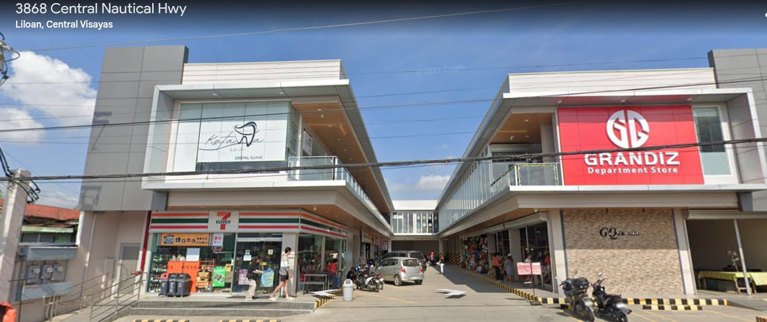Actual Location*

*Satellite map of the business location and other establishments around the area*

**BUSINESS LAYOUT**

Since the building is already established, All Rice will only be responsible for paying the monthly rent, allowing the business to save on construction costs. The location has a total area of 40 square meters, providing sufficient space for product display, storage, and customer transactions. This setup ensures a practical and cost-efficient approach to establishing the business while offering a convenient and accessible environment for customers.

**Floor Plan**

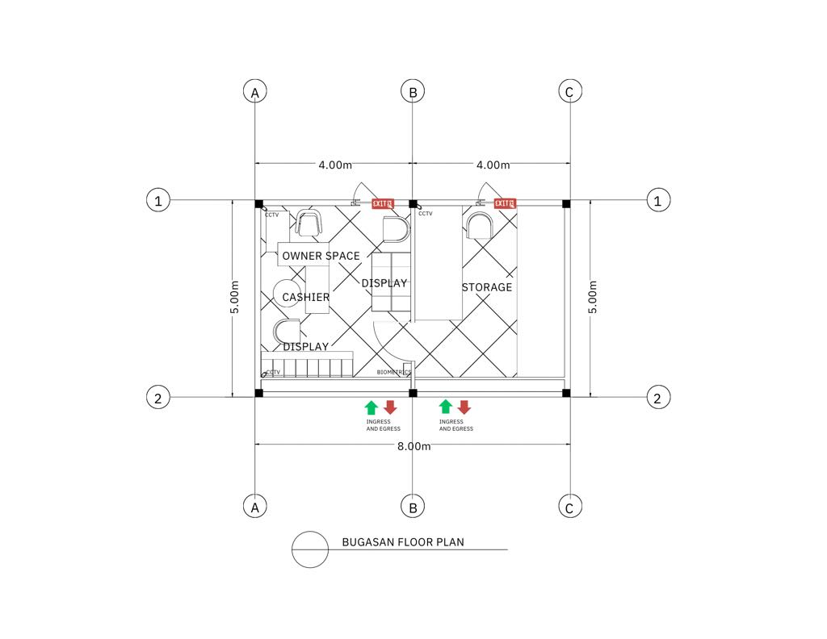

**Front View**

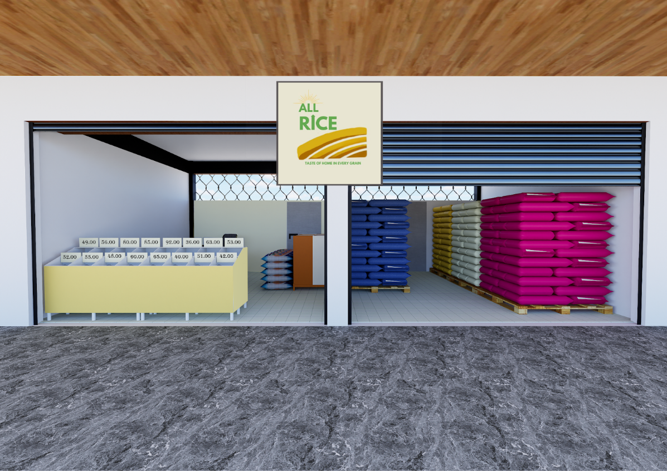

Inside View



Side View



Storage View

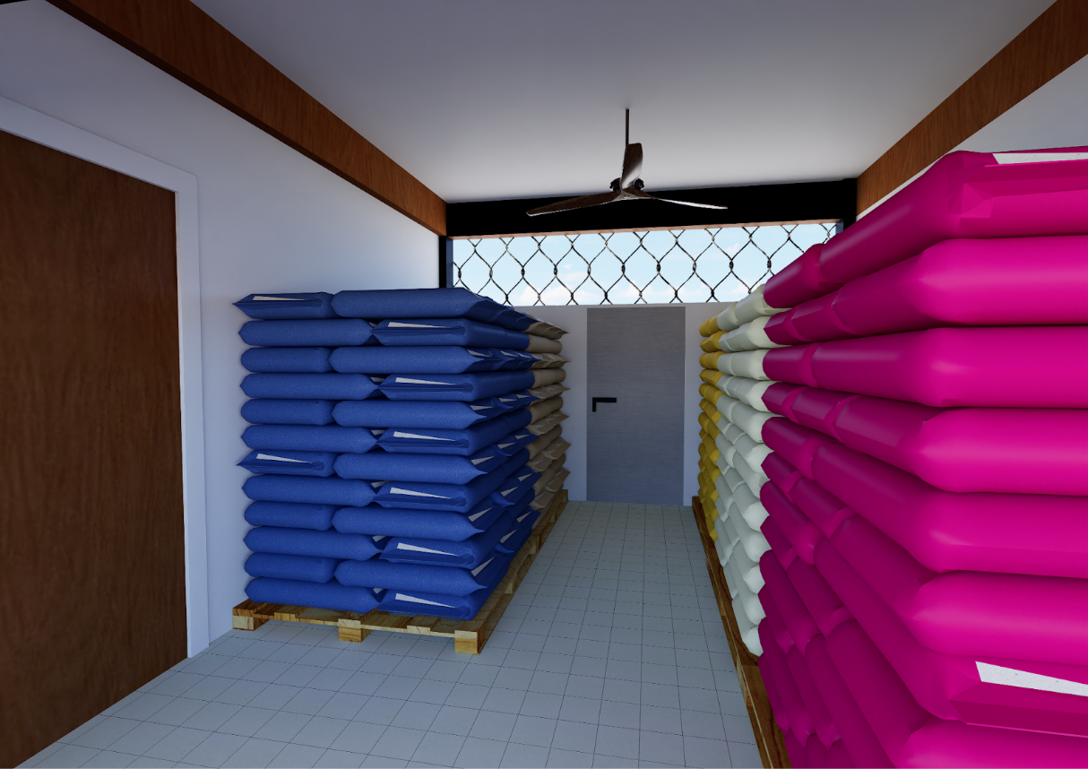

**Leasehold Improvement**

|  |  |  |  |  |
| --- | --- | --- | --- | --- |
| **Quantity** | **Item** | **Supplier** | **Unit Cost** | **Total Cost** |
| 8pcs | Primer |  | 258 | 2,064 |
| 14pcs | Paint (Acrylic) |  | 308 | 4,312 |
| 2pcs | Door |  | 1,200 | 2,400 |
| 2pcs | Roll up Door |  | 10,000 | 20,000 |
| 5Meters | Wires |  | 34 | 170 |
| 4pcs | Gang Switch |  | 80 | 320 |
| 4pcs | Pin Light |  | 180 | 720 |
| 2pcs | Led Light |  | 90 | 180 |
| 5pcs | Receptacle |  | 85 | 425 |
| 2pcs | Breaker |  | 929 | 1,858 |
| 10 sheets | Marine Plywood |  | 620 | 6,200 |
| 1kg | Finishing Nail |  | 110 | 110 |
| 10pcs | Sandpaper |  | 12 | 120 |
| 5pcs | Rags |  | 5 | 25 |
| 5pcs | Paint Brush |  | 55 | 165 |
| 3pcs | Roller |  | 120 | 360 |
| **TOTAL** | | | | **39,429** |

**Labor Cost for Leasehold Improvement**

|  |  |  |  |
| --- | --- | --- | --- |
| **Items** | **Service Cost Per Day** | **Working Days** | **Total Cost** |
| Panday | 600 | 7 | 4,200 |
| Painter | 800 | 7 | 5,600 |
| Electrician | 1600 | 7 | 11,200 |
| **Total** | | | **21,000** |

**Leasehold Improvements Estimated Total Cost**

|  |  |
| --- | --- |
| Leasehold Improvement Cost | ₱39,429 |
| Labor Cost | ₱21,000 |
| **TOTAL** | **₱60,429** |

**Utilities**

Utilities are essential in business as they facilitate the smooth operation of activities within the organization. The source of the electricity in the business are Visayan Electric Company (VECO), and the internet connection by Globe Telecom. The electricity bill, and internet connection bill will be payable every month.

**Utilities Expense**

|  |  |  |  |
| --- | --- | --- | --- |
| **Particulars** | **Supplier** | **Estimated Consumption Per Month** | **Estimated Consumption Per Year** |
|
|
| Electricity | VECO | ₱1,000.00 | ₱12,000.00 |
| Internet Connection | GLOBE | 1,399.00 | 16,788.00 |
| **TOTAL:** | | **₱5,399.00** | **₱28,788.00** |

**Gasoline Fee**

|  |  |  |  |
| --- | --- | --- | --- |
| **Particulars** | **Supplier** | **Estimated Consumption Per Month** | **Estimated Consumption Per Year** |
| Gasoline | Petron | 4000.00 | 48,000.00 |
| **TOTAL:** | | | 48,000.00 |

**Promotional Fee**

|  |  |  |  |
| --- | --- | --- | --- |
| **Particulars** | **Supplier** | **Estimated Consumption Per Month** | **Estimated Consumption Per Year** |
| Printing of Fleyers and Loyalty Cards | CopyWell | 1,000.00 | 12,000.00 |
| **TOTAL:** | | | **12,000.00** |

**Salaries Expense Per Month**

|  |  |  |  |
| --- | --- | --- | --- |
| **Employee** | **Rate per day** | **Every 15th day of the month** | **Every 30th day of the month** |
| SALES ASSISTANT | 350 | 4550 | 9100 |
| SALES ASSISTANT | 350 | 4550 | 9100 |
| UTILITY HELPER | 350 | 4550 | 9100 |
| **TOTAL** | **1,050** | **13,650** | **27,300** |

**Salaries Expense**

|  |  |  |  |
| --- | --- | --- | --- |
| **Employee** | **Monthly** | **13th Month** | **Annually** |
| SALES ASSISTANT | 9100 | 9100 | 109,200 |
| SALES ASSISTANT | 9100 | 9100 | 109,200 |
| UTILITY HELPER | 9100 | 9100 | 109,200 |
| **TOTAL** | **27,300** | **27,300** | **327,600** |

**Prepaid Rent**

|  |  |  |  |
| --- | --- | --- | --- |
| **Particular** | **Location** | **Monthly Cost** | **Annual Cost** |
| Rent | Brgy. Yati, 4131 Cebu North Road | ₱15,600.00 | ₱187,200.00 |
| TOTAL: | | ₱15,600.00 | ₱187,200.00 |

**Direct Labor Cost**

|  |  |
| --- | --- |
| **PERSONNEL** | **ANNUAL COST** |
| Sales Assistant | 109,200 |
| Sales Assistant | 109,200 |
| Utility Helper | 109,200 |
| 13th Month | 41,600 |
| SSS | 16,380 |
| Pag-IBIG | 4,368 |
| PhilHealth | 6000 |
| **TOTAL** |  |

**Overhead Cost**

|  |  |
| --- | --- |
| Leasehold Improvement Amortization Cost |  |
| Depreciation Expense |  |
| **TOTAL** |  |

**Depreciation Expense and Amortization Cost**

All Rice uses the straight-line method of amortizing and depreciating the fixed asset.

* Leasehold Improvement Cost         **₱63,729/ 10yrs = ₱6372.9**
* Labor Cost                                      **₱27,569/ 10yrs = ₱2,756.9**

**PERMIT AND LICENSES**

Permits and licenses are official approvals required by All Rice to operate legally. These are necessary to ensure compliance with local regulations, allowing the business to function without legal hindrances. Obtaining the required permits and licenses is crucial for maintaining smooth operations and avoiding potential penalties.

|  |  |
| --- | --- |
| **Particulars** | **Prices** |
| Barangay Clearance |  |
| DTI Business Name Registration |  |
| Business Permit / Mayor’s Permit |  |
| BIR Certificate of Registration (COR) |  |
| Sanitary Permit |  |
| NFA License |  |
| Fire Safety Inspection Certificate |  |
| Building Permit/Renovation Permit |  |
| SSS, PhilHealth, and Pag-IBIG Registration |  |
| BMBE Certificate of Authority |  |
| **TOTAL:** |  |

**COSTING PER PRODUCT**

Costing per product refers to the price at which All Rice acquires each unit of rice for resale. It is the cost incurred to obtain the product, which is then marked up to determine the selling price. This markup ensures that All Rice generates a profit while maintaining a competitive price for customers.

**PER KILO**

|  |  |  |  |
| --- | --- | --- | --- |
| **Products** | **Purchase Cost Per kilo** | **Mark-up 9%** | **Selling Price** |
| Ivory | 47 | 4 | 51 |
| Ganador | 49 | 4 | 53 |
| Princess Bea | 42 | 4 | 46 |
| Doña Conchita (Orange) | 51 | 5 | 56 |
| Doña Conchita (Blue) | 44 | 4 | 48 |
| Brown Rice | 50 | 5 | 55 |
| Corn Rice 14 | 36 | 3 | 39 |
| Corn Rice 16 | 37 | 3 | 40 |
| Glutinous Rice | 54 | 5 | 59 |

**PER 5 KLS**

|  |  |  |  |
| --- | --- | --- | --- |
| **Products** | **Purchase Cost Per kilo** | **Mark-up 7%** | **Selling Price** |
| Ivory | 240.50 | 17 | 258 |
| Ganador | 250.50 | 18 | 269 |
| Princess Bea | 220 | 15 | 235 |
| Doña Conchita (Orange) | 245 | 16 | 261 |
| Doña Conchita (Blue) | 233 | 16 | 249 |
| Brown Rice | 235 | 16 | 251 |
| Corn Rice 14 | — | — | — |
| Corn Rice 16 | — | — | — |
| Glutinous Rice | — | — | — |

**PER 10 KLS**

|  |  |  |  |
| --- | --- | --- | --- |
| **Products** | **Purchase Cost Per kilo** | **Mark-up 8%** | **Selling Price** |
| Ivory | 477 | 38 | 515 |
| Ganador | 497 | 40 | 507 |
| Princess Bea | 450 | 36 | 486 |
| Doña Conchita (Orange) | — | — | — |
| Doña Conchita (Blue) | — | — | — |
| Brown Rice | 470 | 38 | 508 |
| Corn Rice 14 | — | — | — |
| Corn Rice 16 | — | — | — |
| Glutinous Rice | — | — | — |

**PER 25 KLS**

|  |  |  |  |
| --- | --- | --- | --- |
| **Products** | **Purchase Cost Per kilo** | **Mark-up 5%** | **Selling Price** |
| Ivory | 1160 | 58 | 1218 |
| Ganador | 1210 | 60 | 1270 |
| Princess Bea | 1125 | 56 | 1181 |
| Doña Conchita (Orange) | 1285 | 64 | 1349 |
| Doña Conchita (Blue) | 1125 | 56 | 1181 |
| Brown Rice | 1100 | 55 | 1155 |
| Corn Rice 14 | — | — | — |
| Corn Rice 16 | — | — | — |
| Glutinous Rice | — | — | — |

**PER 50 KLS**

|  |  |  |  |
| --- | --- | --- | --- |
| Products | Purchase Cost Per kilo | Mark-up 3% | Selling Price |
| Ivory | 2310 | 69 | 2379 |
| Ganador | 2410 | 72 | 2482 |
| Princess Bea | 2100 | 63 | 2163 |
| Doña Conchita (Orange) | 2520 | 76 | 2596 |
| Doña Conchita (Blue) | 2200 | 66 | 2266 |
| Brown Rice | — | — | — |
| Corn Rice 14 | 1220 | 37 | 1257 |
| Corn Rice 16 | 1240 | 37 | 1277 |
| Glutinous Rice | 2290 | 69 | 2359 |

**MERCHANDISE PER PRODUCT**

Merchandise per product refers to the cost of goods purchased by All Rice for resale within a month. It represents the total amount spent on rice purchased for selling to customers, serving as a key monthly expense. This ensures that All Rice maintains sufficient inventory to meet customer demand while avoiding over-purchasing.

**RICE PER SACK (5 KILOGRAMS)**

|  |  |  |  |  |
| --- | --- | --- | --- | --- |
| **QTY (kilos)** | **Items** | **Supplier** | **Purchase Cost Per Sack** | **Total Cost** |
|
| 20 | Ivory | Wensor Trading | 240.50 | 4,810 |
| 20 | Ganador | Wensor Trading | 250.50 | 5,010 |
| 15 | Princess Bea | Wensor Trading | 220 | 3,300 |
| 10 | Doña Conchita(Blue) | Wensor Trading | 245 | 2,450 |
| 10 | Doña Conchita (Orange) | Wensor Trading | 233 | 2,330 |
| 20 | Brown Rice | LT Trading | 235 | 4,700 |
|  | Corn Rice (#14) | Wensor Trading | — | — |
|  | Corn Rice (#16) | Wensor Trading | — | — |
|  | Glutinous Rice | Wensor Trading | — | — |
| **Total** | | | |  |

**RICE PER SACK (10 KILOGRAMS)**

|  |  |  |  |  |
| --- | --- | --- | --- | --- |
| **QTY (kilos)** | **Items** | **Supplier** | **Purchase Cost Per Sack** | **Total Cost** |
|
| 20 | Ivory | Wensor Trading | 477 | 9,540 |
| 20 | Ganador | Wensor Trading | 497 | 9,940 |
| 15 | Princess Bea | Wensor Trading | 450 | 6,750 |
|  | Doña Conchita(Blue) | Wensor Trading | —- | — |
|  | Doña Conchita (Orange) | Wensor Trading | —- | — |
| 20 | Brown Rice | LT Trading | 470 | 9,400 |
|  | Corn Rice (#14) | Wensor Trading | —- | —- |
|  | Corn Rice (#16) | Wensor Trading | —- | —- |
| **Total** | | | |  |

**RICE PER SACK (25 KILOGRAMS)**

|  |  |  |  |  |
| --- | --- | --- | --- | --- |
| **QTY (kilos)** | **Items** | **Supplier** | **Purchase Cost Per Sack** | **Total Cost** |
|
| 20 | Ivory | Wensor Trading | 1,160 | 23,200 |
| 20 | Ganador | Wensor Trading | 1,210 | 24,200 |
| 15 | Princess Bea | Wensor Trading | 1,125 | 16,875 |
| 15 | Doña Conchita(Blue) | Wensor Trading | 1,285 | 19,275 |
| 15 | Doña Conchita (Orange) | Wensor Trading | 1,125 | 16,875 |
| 15 | Brown Rice | LT Trading | 1,100 | 16,500 |
|  | Corn Rice (#14) | Wensor Trading | —- | —- |
|  | Corn Rice (#16) | Wensor Trading | —- | —- |
|  | Glutinous Rice | Wensor Trading | —- | —- |
| **Total** | | | |  |

**RICE PER SACK (50 KILOGRAMS)**

|  |  |  |  |  |
| --- | --- | --- | --- | --- |
| **QTY (kilos)** | **Items** | **Supplier** | **Purchase Cost Per Sack** | **Total Cost** |
|
| 20 | Ivory | Wensor Trading | 2,310 | 46,200 |
| 20 | Ganador | Wensor Trading | 2,410 | 48,200 |
| 15 | Princess Bea | Wensor Trading | 2,100 | 42,000 |
| 15 | Doña Conchita(Blue) | Wensor Trading | 2,520 | 50,400 |
| 15 | Doña Conchita (Orange) | Wensor Trading | 2,200 | 44,000 |
|  | Brown Rice | LT Tradingg | —- | —- |
| 20 | Corn Rice (#14) | Wensor Trading | 1,220 | 24,400 |
| 20 | Corn Rice (#16) | Wensor Trading | 1,240 | 24,800 |
| 5 | Glutinous Rice | Wensor Trading | 2290 | 11,450 |
| **Total** | | | |  |

**Total Project Cost**

**Estimated Project Cost**

**Initial Capital Outlay**

         Store Equipment

             Furniture and Fixture

             Leasehold Improvement

             Total Investment in Fixed Assets

**Initial Working Capital**

             Merchandise Inventory

             Store Supplies

             Utilities Expense

             Rent Expense

**Total Initial Working Capital**

**Pre-operating Expense**

         Permits and Licenses Expense

**Total Pre-Pre-operating Expense**

TOTAL

ADD: Petty Cash

**TOTAL PROJECT COST**